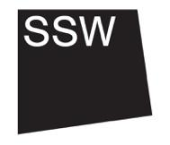
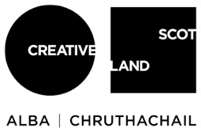

- About Scottish Sculpture Workshop (SSW)
This is Section 2/8

SSW is an arts organisation based in Lumsden, Aberdeenshire. We empower artists and communities through collective learning and skills development.

Our programme and rural workshops support experimentation, alternate knowledge production and artistic desire. We question the narratives of our location and critically engage with the urgent issues of our time, through artist-led projects, residency, open access and international collaboration.

We build meaningful connections with the material world and each other.

Read more about our vision and values on our website.

