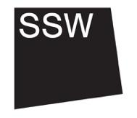

- About the role
This is section 3/8

As the Programme and Communications Fellow, you will work closely with the SSW team, artists, project partners and our local community in Lumsden. We will work collaboratively on artist-led projects and artist residencies, communication and administration among other tasks.

In all areas of this work, you will be an active part of our collective conversations, decision making, caregiving and collaborative learning, and your perspectives and ideas will feed into the activities of the organisation.

We want to work with someone who is passionate about the potential of the arts in supporting social justice, and someone who is excited to work with and support artists. You should be practical and down-to-earth, comfortable working collaboratively and open to mutual learning and exchange. We hope that you will be interested in our workshop facilities, international working and our upcoming programmes, and are committed to working in and learning from a rural context.

