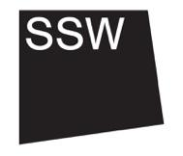
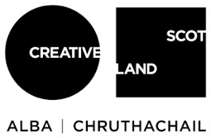

- Skills and experience we are looking for
This is section 4/8

The Weston Jerwood Creative Bursaries are specifically for people who identify as coming from a lower socio-economic background. By this we mean as working class or from lower-income backgrounds. There is more information about this in Section 8 of this pack.

We are looking for someone who is at an early stage of their career and is based in Scotland, who can bring diverse experiences and skills to the role. These could come from experience at work (in the arts or other sectors) or could come from things you do in your spare time. These could also come from a personal artistic practice, volunteering, personal interests and/or lived experience, among others.
Together with areas of work which focus on equalities, diversity and inclusion, addressing structural barriers to the arts and accessibility, this role will involve working on artist-led projects which centre the work and experiences of Black, Indigenous and People of Colour (BIPOC) within rural Scotland (see section 5 for more details). The successful person must therefore have an understanding of the lived experiences of Black, Indigenous and People of Colour as this is a current gap within the majority white SSW team.

Experience, skills and abilities:
- Enjoy working with others, open to mutual exchange and learning
- Skilled in organising and planning ahead, for projects and your own workload
- Enjoy meeting new people, able to understand and support their diverse needs with sensitivity and generosity
- Good at thinking on your feet and adapting to change
- IT confident, ideally with MS Office, Google Drive and digital communication platforms (we can provide training if not, but you must be comfortable working on a computer)
- Able to balance multiple priorities and work constructively as part of a small team
- Keen to develop your writing skills for varied platforms and audiences
- Good attention to detail
- Be active in your learning and comfortable taking initiative

Personal attributes and interests:
- Have an understanding of the lived experiences of Black, Indigenous and People of Colour
- Have a practical, hands on and down-to-earth approach
- Committed to equalities, diversity and inclusion
- Passionate about addressing structural inequalities in the arts in Scotland
- Keen to work with and support artists
- Interest in and some knowledge of the arts in Scotland (this could include writing, theatre, contemporary art, live art, sound or music among other art forms)
- Interested in SSW’s workshop facilities, international working, rurality, accessibility, environmental concerns, and exploring the points at which these intertwine

