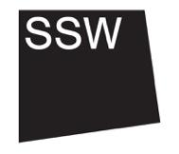
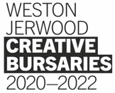
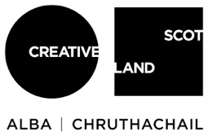

8. About the Weston Jerwood Creative Bursaries
This is Section 8/8

Weston Jerwood Creative Bursaries Programme 2020-22
This document is available to read in Easy Read format, listen to as an audio recording or watch in BSL video.
Cymraeg
Os byddai’n well gennych chi ddarllen fersiwn Cymraeg o’r testun hwn, cliciwch yma.
Os byddai’n well gennych chi wrando ar y testun hwn, cliciwch yma.
Os byddai’n well gennych chi weld fersiwn Hawdd i’w Ddarllen o’r testun hwn, cliciwch yma.

This job is part of a wider programme called the Weston Jerwood Creative Bursaries, which is designed and run by Jerwood Arts.

Who are we and what do we stand for?

Jerwood Arts is an independent arts funder, and we work with early-career artists, curators and producers to help them gain access to opportunities, collaborate with other artists and get ideas and projects off the ground. Sometimes we work with artists directly, and sometimes we work with organisations.
Together with organisations like the one you are considering applying to, we also advocate for the arts and cultural sector to be a more equitable and inclusive place to work. There is a wealth of information, data and academic research about the lack of diversity in the arts, and artists and arts workers continue to face exclusion based on their class origins, ethnicity, disability, gender, and other elements of their background, identity or experience. We think the system is broken, and that positive action combined with deep work by organisations is the only way for this to change. For this reason, the Weston Jerwood Creative Bursaries programme is only for those from low socio-economic backgrounds. It is also an Arts Council England Transforming Leadership programme, which is looking to nurture future leadership in the arts.
What is a low socio-economic background?
If you are from a low socio-economic background, you will most likely have been to state school, might have received free school meals as a child, or had a precarious household income when you were growing up. You might have grown up in the care system, been a young carer, or been the first in your family to go to university. Other terms people from a low socio-economic background might identify themselves with are working-class or benefit-class. If you are from a low socio-economic background you are more likely to face intersecting barriers in society, experiencing racism, ableism and other forms of discrimination. You can find out more about socio-economic diversity and inclusion, and the actions we are advocating for, in this Toolkit.

How it works

The programme funds year-long salaried jobs in arts and cultural organisations, as well as providing links to wider professional and pastoral guidance where it is needed. It seeks to interrogate and remove barriers to entry and enable people to build careers in the arts with confidence and support. Over 2020-2022, we are funding 50 jobs across a range of art forms – you can read about the full list of opportunities here.

What will you get from the programme beyond the job?
- Fellows Network: If you get this job, you will become part of a network with 49 other artists, curators and producers from low socio-economic backgrounds. We call this a network of ‘Fellows’. You will all be near the beginning of your life as professional artists and creatives, starting new jobs within three months of each other. It is likely that you might have faced similar and interconnecting barriers to working in the arts previously. Navigating institutions and new professional contexts can be tough, but you won’t be doing it alone. In the past the network has produced friendships, artistic collaborations, theatre companies and a sense of community.
- Professional Development: Fellows will join the Professional Development programme led by people make it work, which will provide support and training and will be co-created with you. This means that we will tailor the content to your needs, challenges and ambitions and work with you to ensure you learn exactly what you need to support your professional development. A key feature of this will be establishing the Fellows Network for shared learning. This programme will be delivered online, and we hope that at the end we can hold an event that brings the Fellows together in a physical space. The programme will take place over a series of live digital meetings that will enable you to get to know each other, meet and learn from alumni and share your experience of starting your new roles. These sessions will respond to your needs in terms of skills development and we imagine that some of the workshops might include networking and career progression, training as a freelancer, public speaking, CV writing and navigating organisations.
- Mentor: You will get a mentor (outside your Host organisation) to work with during your Fellowship. Who they are is completely up to you, and we will pay for their time. You’ll also receive guidance from Arts Emergency who have significant experience in how to identify and make the most of a mentor.
- Progression: Throughout the programme, you’ll be supported by your Host organisation and Jerwood Arts to help you work out your next steps after the year is over. This might be coaching, support with future job and funding applications, introductions to programmers and funders, or simply advice and encouragement. Jerwood Arts can provide £1,000 of additional funding specifically to support your own creative projects, research and collaborations towards the end of your time on the programme.
- Feedback: We’ve run this programme three times over the past decade (you can hear about other peoples’ experiences of the programme here). Each time we learn more about what works and what doesn’t, so you will be encouraged to speak to both Jerwood Arts and your Host organisation if there’s anything you’d like us to reflect on, build on or change to improve it for you.
If you love the sound of the job but have questions about the Weston Jerwood Creative Bursaries programme as a whole, you’re welcome to contact Sarah Gibbon, Project Manager at Jerwood Arts, confidentially on sarahg@jerwoodarts.org or 07944 903989 in advance of making an application.
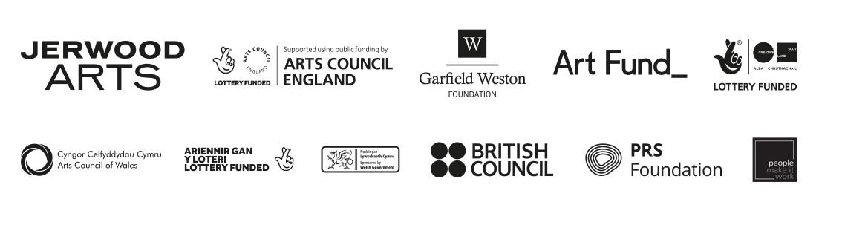
Please note that if your questions are specific to the job role or the application process, these should be directed to the organisation you’re applying to. You should find information about who to contact within the job pack.
The Weston Jerwood Creative Bursaries 2020-2022 programme is designed and produced by Jerwood Arts. It is funded and supported by Arts Council England’s Transforming Leadership Fund, Garfield Weston Foundation, Art Fund, Arts Council of Wales, The National Lottery through Creative Scotland, British Council, Jerwood Arts
and PRS Foundation

