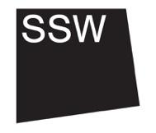
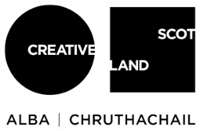

- Equal Opportunities and Access
This is Section 6/7

We are committed to creating a team that reflects the diversity of lived experience in our society. We actively encourage people who are underrepresented in the arts to apply for jobs at SSW and are particularly keen to receive applications from Black, Indigenous and People of Colour, and disabled candidates.

To achieve equal opportunities in all stages of our recruitment practices we are taking positive actions. These include:
At application:
- Rewriting our job packs and shifting the language we use
- Creating a more inclusive application process, with no requirement for CVs and the choice to submit in various formats
- The creation of additional resources to support applicants in writing an application, such as FAQs and audio recordings
- Considerate advertising of jobs to encourage those who do not see themselves represented to apply
- Offering time to talk to potential applicants to support in thinking about or articulating how their experiences are transferable to the role
- All disabled candidates who demonstrate that they meet the required skills and experience for the role will be invited for an interview.
At interview:
- Creating budgets to support access at interview stage (in person / remote)
- Bringing artists into the selection and decision-making process
- Ensuring interview panels are more representative of diverse and intersecting identities

On decision making:
- Offering feedback and additional support to unsuccessful applicants where possible

We encourage all applicants to complete our equal opportunities monitoring form as this helps us measure the diversity of our organisation and our work.

