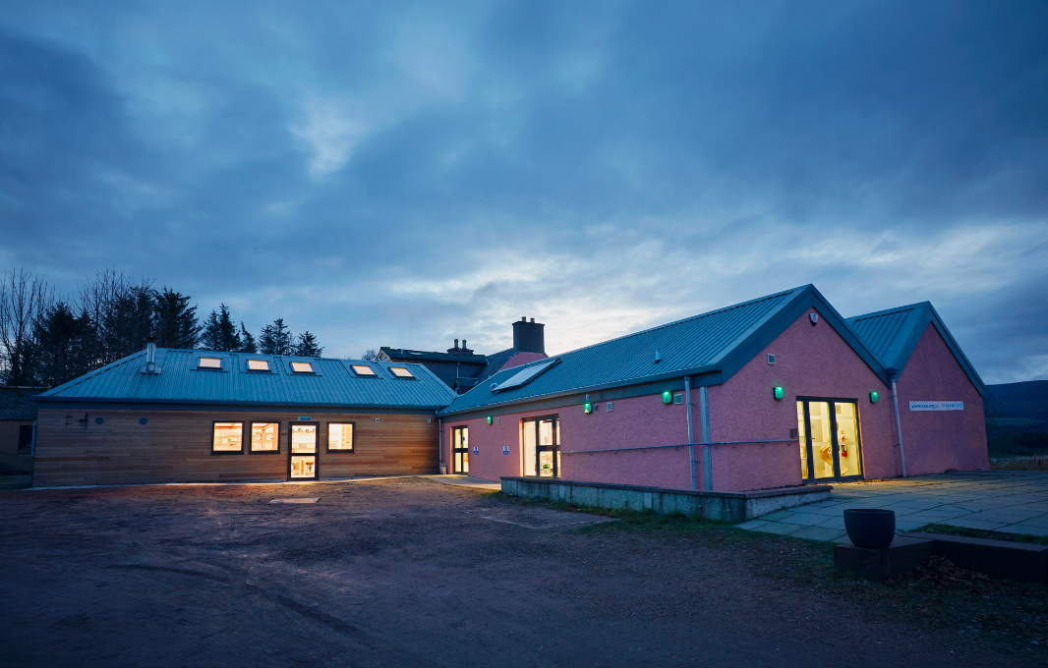

All images by Felicity Crawshaw

Ceramics Technician at Scottish Sculpture Workshop
Job Pack

ssw.org.uk

For other formats please email arts@ssw.org.uk
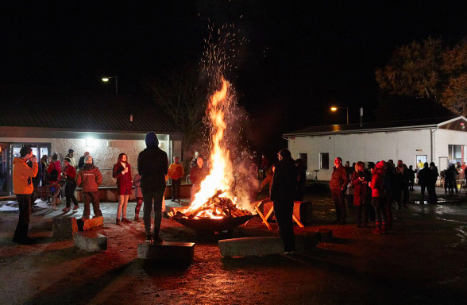

About SSW

SSW empowers artists and local communities through collective learning and making, material experimentation and skills development. Our programme of residencies, open access, courses and community learning build meaningful connections with the material world and each other.

We are driven by experimentation - testing out ways of working with a range of materials and ideas led by the process. We work in partnership with many organisations, institutions and individuals building and maintaining networks that are local, national and international.

The successful candidate will be joining SSW in an exciting transitional year that places focus on the ceramics facility and programme following a recent capital development of this area. This year we are also developing a new strategic plan which the successful Ceramics Technician will be able to feed into as part of the staff team. It is an opportunity to work with the SSW Director on the ceramics programme development for 2024 growing opportunities for expanding ceramics at SSW alongside developing income generation, artist support and development opportunities and community learning.

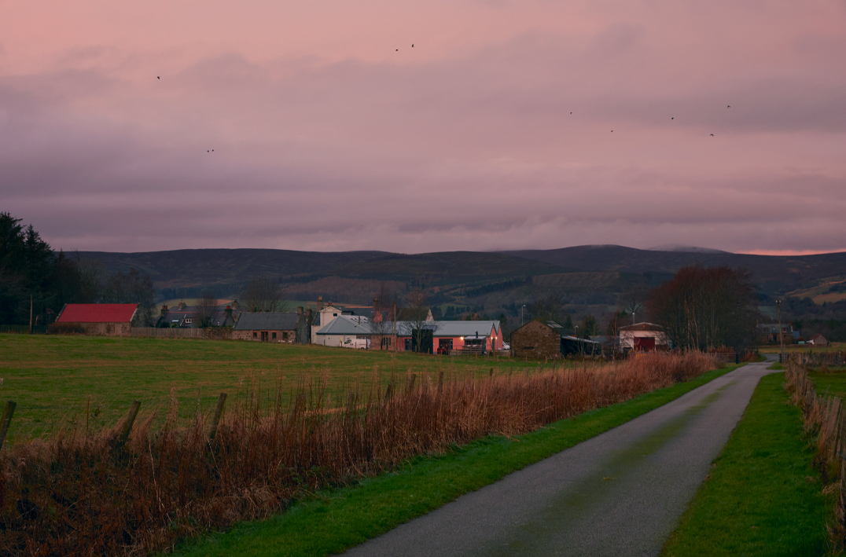

About SSW’s site and surrounding area

SSW is the former village bakery that was developed into Scottish Sculpture Workshop by artist Fred Bushe in 1979. The site includes the recently renovated ceramics studio, artists studio, a new Community Making Space, on and off site accommodation and shared office space. It houses a purpose built foundry, wood and metal workshop and outdoor forge - which are not in use this year as we prepare for their future development over the coming years. The original bothy is a shared space for eating and socialising with an adjacent artist built sauna.

SSW is located in Lumsden, a small village in North East Scotland with around 300 inhabitants. In Lumsden, there is a village hall, primary school and car garage with a small shop. The village is surrounded by farmland, moorland and hills, with hills The Buck and Tap O’Noth rising to the North and West, and Bennachie to the East. We are on the main road between towns Alford and Huntly. Lumsden is a 15 minute drive from the Cairngorms National Park, and a short drive to many castles, whisky trails and a wide range of outdoor facilities and pursuits. The North East coast has beautiful beaches and cliff walks, while more locally there are lots of historic sites to explore. The nearest city is Aberdeen. It is approx. one hour’s drive to the south east with train stations within a 20 minute drive of SSW.

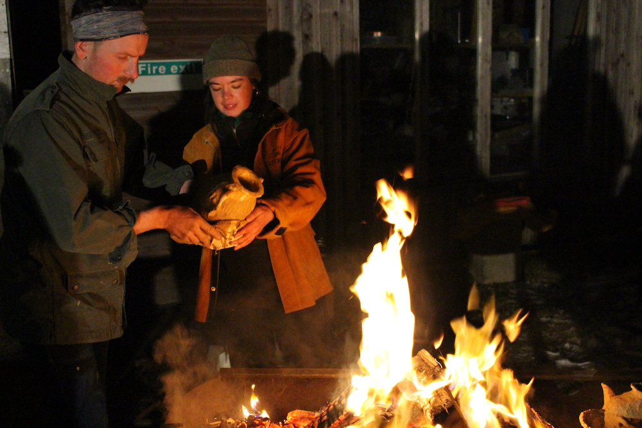

About the role

Job Title: Ceramics Technician
Salary: £23,000 - £27,000 (pro-rata) depending on experience, valid certifications and training
Pension: 5% pension contribution
Contract: 0.8 (4 days per week) fixed term for 2 years includes working weekends and evenings as required
Reporting to: Director
Holiday: 22 days + 10 bank holiday (10 days bank holidays to be taken over the set winter closure in December/ January).
TOIL: Overtime is paid through TOIL which must be outlined and agreed in advance with line managers.
Place of work: SSW, Lumsden, Aberdeenshire, Scotland
Use of workshops: Access to the workshops and facilities for your own art projects with prior arrangement from the Director.

Deadline for Applications: Friday 7 April 2023, midday
Interview: Tuesday 18 April
Commencement of role: May 2023

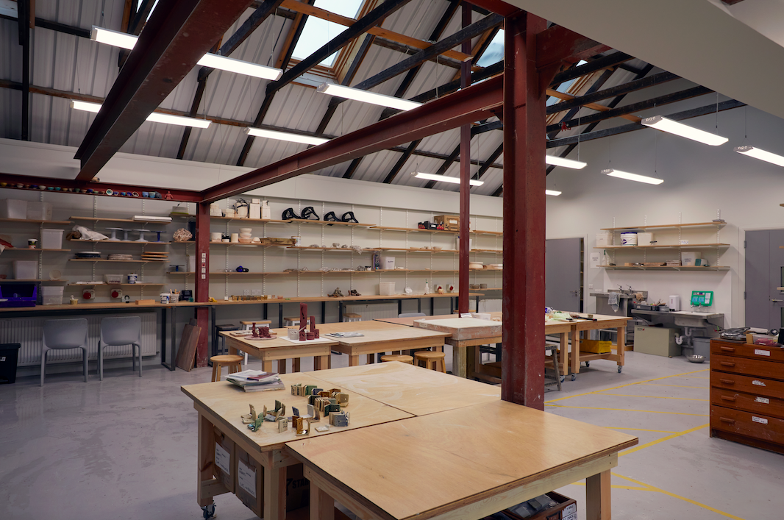

Job Description

Overview
The ceramics technician is responsible for the delivery of all aspects of SSWs work in clay, ceramics and related mouldmaking and will provide high-quality technical support to artists from a range of backgrounds and disciplines, community learners and other external users.
The role will support and oversee the ceramic workshop and associated areas and processes at SSW. It requires extensive operational and technical knowledge of clay processes and practices, kiln (electric, raku, wood fired) maintenance/ firing and glazing, alongside robust Health and Safety practices in order to support artists and local communities to work within a safe and engaging environment.
The successful candidate will be able to support and facilitate the work and ideas of a wide range of people with differing experiences of working in clay - from beginners through to professionals. They will demonstrate an ability to lead a studio and maintain the associated health and safety responsibilities attached to this. They must be highly aware of the current HSE guidance and health and safety legislation and regulations to ensure a safe and compliant work space.
They should provide a warm, welcoming and accessible environment for artists, community members and staff, be a strong communicator and have a can-do attitude to supporting artists' practice. They will be able to work closely with colleagues as well as independently, have experience of working within the arts and supporting contemporary artists practice and be able to ensure effective working relationships with the SSW team and users.They will also be able to feed into developing the ceramics programme. We are particularly interested in people who are committed to the transformational potential of clay both within society and the contemporary visual arts.
We are committed to making our space open and accessible and are continuing to develop our diversity, inclusion and equality plans this year. As such they should enable a supportive and safe learning environment across SSW and be active in their learning in this area.
Facilities
- Leading the day-to-day running of the SSW ceramic workshop for artists and other users within this space
- Provide practical support and technical guidance to artists and ceramic users to achieve their ideas and learn a range of ceramic processes and outcomes.
- Upkeep of the ceramic facilities - ensuring the workshop and associated equipment is well maintained and meets high health and safety standards.
- Maintain the kilns and ensure their safe use, including loading, unloading, firing, and kiln shelf maintenance.
- Manage technical and firing schedules and communicate these timelines with users
- Operate and maintain machinery, equipment and tools associated with the ceramics facilities.
- Ensure all users of the ceramics facilities have undertaken Health and Safety and Studio Inductions and are informed of protocol of the SSW site and are signed in for all sessions.
- Develop and implement an annual maintenance and H&S schedule for ceramics
- Review and update all risk assessments, COSHH, tool and process inductions.
- Monitor and review all ceramic equipment and facilities and assess when external contractors are required.
- Oversee ceramic, glaze and mould making stock and materials and undertake a quarterly stock take
- Ensure all materials are stored and disposed of safely and appropriately
- Work with SSW team to ensure that materials, tools and equipment are ordered and available to users and kept within budget
- Continue to build on SSW’s existing public glaze library ensuring it is accessible and usable.
- Undertake and record monthly site inspections of the ceramics studio and report any issues to your line manager.

Programme
- Work with SSW Director to support the development of the ceramics programme including courses, open access and other applicable projects focussed on ceramics
- Work closely with the SSW team to ensure clear communication of ideas, opportunities, issues or challenges.
- Attend and contribute to bi-weekly staff meetings and provide a technical report to SSW Director every 3 months.
- Work with SSW Finance team to review and update ceramic costings
- Working with SSW team to support on a range of reporting as appropriate
- Take part in training and visits that will inform organisational and programme development
Artist and community learning support
- Undertake technical check ins with artists prior to their arrival at SSW
- Support in the selection of artists through open call as applicable
- Provide technical support, advice and guidance to artists in the development of their projects and ideas whilst on residency, open access or courses.
- Support induction and orientation of other ceramics course leaders or visiting artists and tutors and ensure they understand and are aware of and adhere to all H&S and related policies and guidance.
- Actively work to hold a caring and open space for all SSW users and team
Other
- Act as a first aider on site at SSW
- Be a key holder for the organisation and emergency contact for users and the building
- Ensure a duty of care to the staff, users and visitors is applied across all activities

Person Specification
Essential

- Strong and proven experience of ceramics making techniques and teaching including the operation and maintenance of kilns and equipment
- Experience of studio management
- Excellent skills in standard ceramics processes and techniques and proven ability to share these with others
- Passionate advocate of the contemporary arts and making practices
- Excellent knowledge of studio health and safety procedures and COSHH
- Creative thinker who can support a range of people with mixed abilities
- Ability to work collaboratively
- Mature ability to maintain and build relationships with wide range of artists, team members and users
- A genuine commitment to the principles of equality, diversity and inclusion
- Strong communication skills
- Holistic approach to learning and teaching
- Excellent communication skills and a friendly and caring attitude to others.
- Excellent computer literacy including confident use of spreadsheets, google suite and integrated booking systems.
- Confidence in ordering materials and communicating with suppliers
- Self-motivated and proactive work ethic, with the ability to work well on your own initiative.
- Creative and artistic skills with a passion for ceramics, with a strong motivation to bring that passion to others.
- Good technical problem solver

Desirable

- Experience of working within artist residencies and open access studios
- COSHH, Risk Assessment training undertaken
- Valid First Aid at Work training
- IOSH managing safely certificate or equivalent
- Interest in developing more environmentally sustainable processes and practices within the ceramics field.

How to apply

Please apply using this online form and by telling us, either in writing of no more than two pages or in a video of up to 5-minutes in length:
- Why you would like to become the ceramics technician at SSW and what you can bring to SSW
- Why the role excites you and what you hope to gain from the post
- Details of your experience and how you meet the points outlined in the JD and person spec.
- Earliest available start date
- The names of two referees (only contacted after seeking permission)

Please also include your CV (maximum 2 pages) and complete our Equal Opportunities Monitoring form (this is for monitoring purposes only and will be detached from your application).

If you would find it more accessible to complete any part of this application in a different format, please email arts@ssw.org.uk.

Please note that the online form does not save automatically so please work on a separate document and upload once you have completed this.

