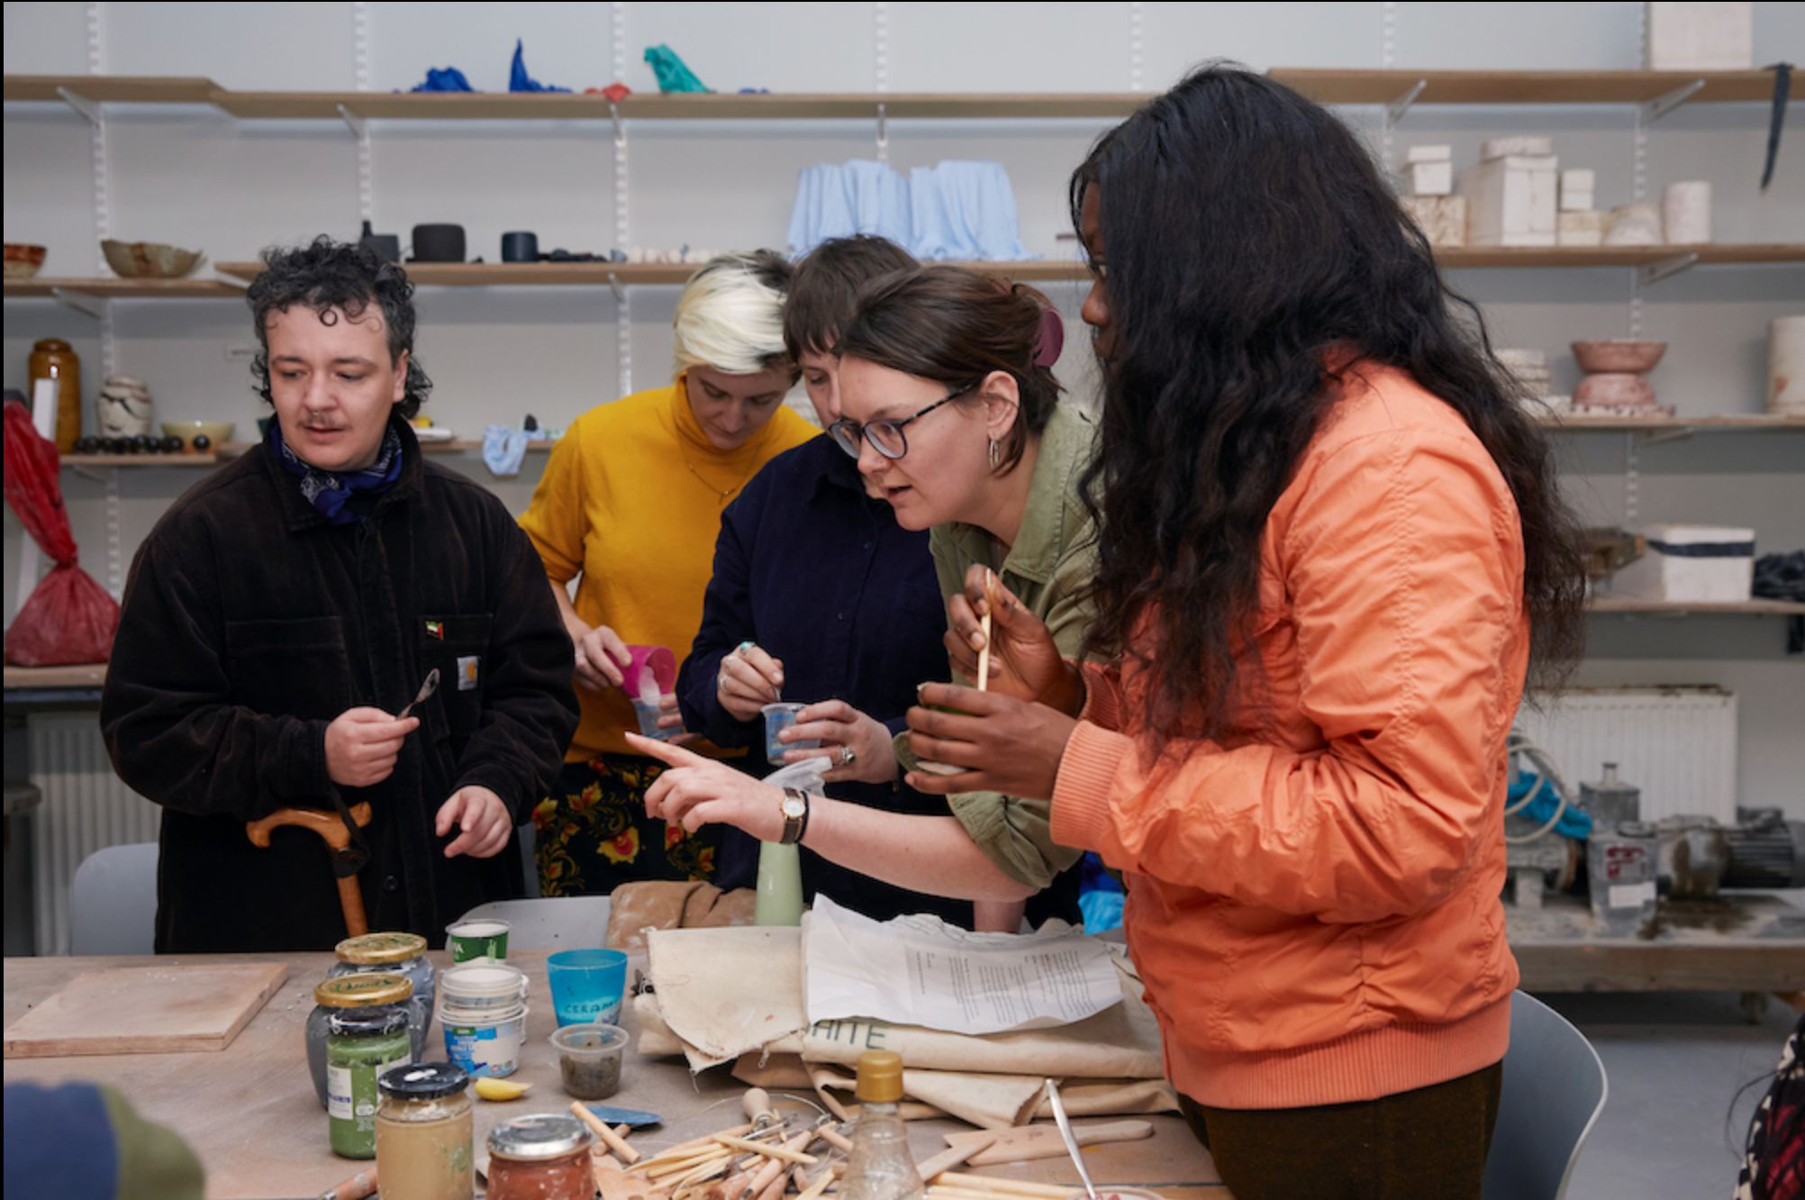
Image by Felicity Crawshaw

Technical Manager at Scottish Sculpture Workshop
Job Pack

Deadline for Applications: 12 March, 12pm
Applicants notified of the outcome: w/c 18 March

Interview: 26 March

Commencement of role: June 2024 is preferred
ssw.org.uk

If you require any access or technical support with the application process please contact arts@ssw.org.uk
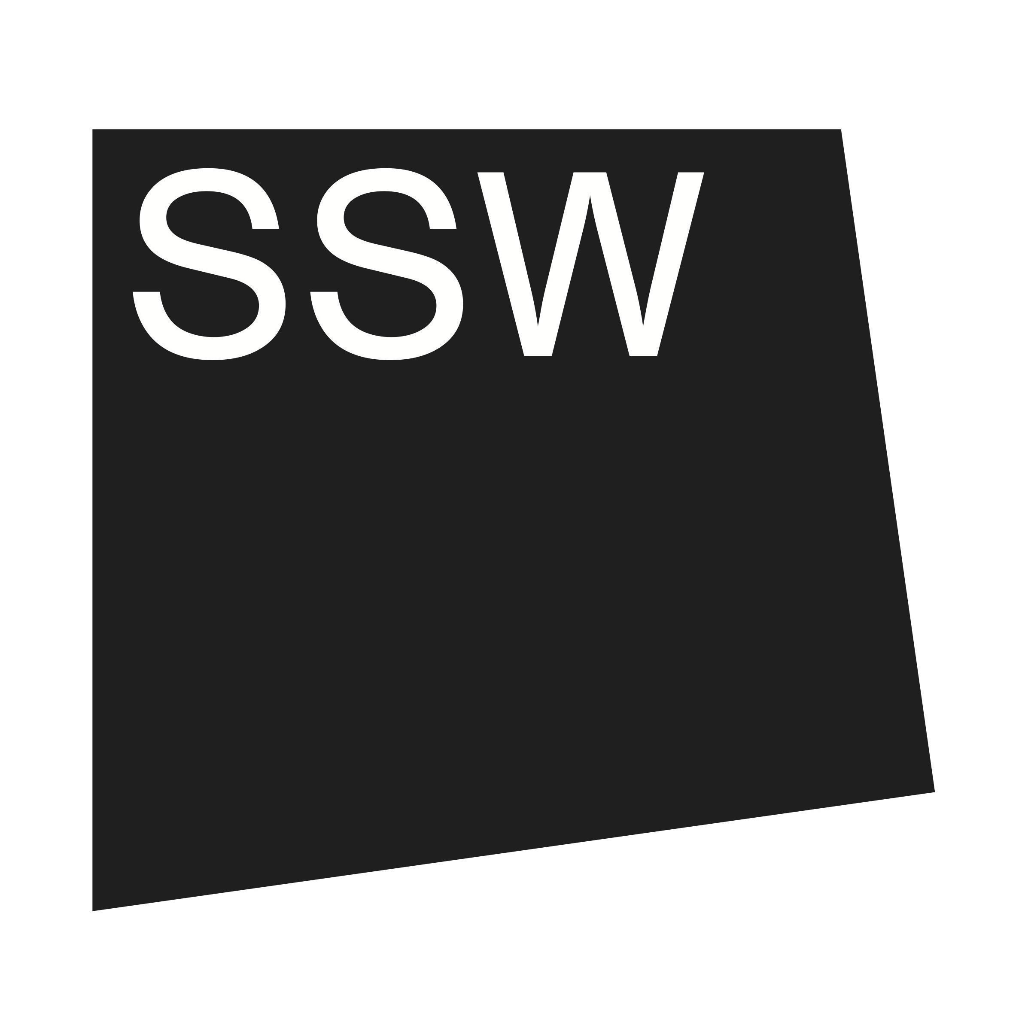
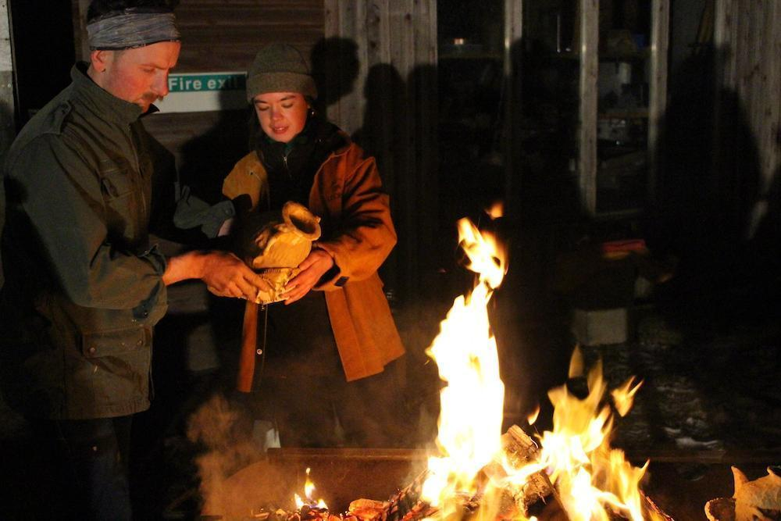

About the Role

Job Title: Technical Manager
Salary: £32,000 – £37,000 (pro-rata) depending on experience, valid certifications and training
Pension: 5% pension contribution
Contract: 0.8 (4 days/ 30 hours per week) permanent may include working weekends and evenings as required
Responsible to: Programmes & Partnerships Director and Finance and Governance Director
Holiday: 22 days + 10 bank holidays (10 days bank holidays to be taken over the set winter closure in December/ January).
Line Manage: Technical Team made up of Ceramics Technician, Visiting Technicians/ Specialists, Cleaner
TOIL: Overtime is paid through TOIL which must be outlined and agreed in advance with line managers.
Place of work: SSW, Lumsden, Aberdeenshire, Scotland. It is a requirement to be onsite to undertake this role.

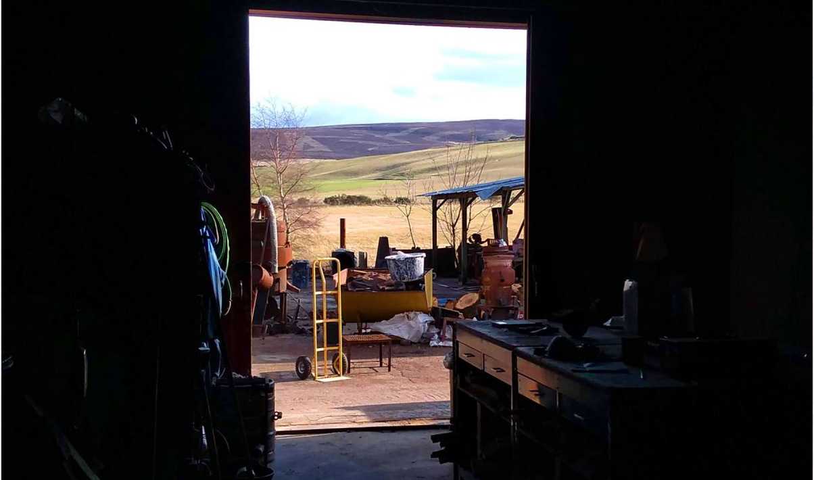
Job Overview
The Technical Manager is a new role, with a supportive pathway towards a Technical Director role to complete our restructured, multi-voiced leadership team for SSW. The role is vital in supporting the organisation to achieve its vision underpinned by our organisational values.
The Technical Manager has responsibility for workshop pedagogy, health and safety, developing and maintaining SSWs site and equipment as well as ensuring that environmental sustainability is prioritised throughout all aspects of the organisation. They will also lead on metal, wood and casting inductions for artists and makers. As such the Technical Manager must have an understanding of practical making in these materials and associated processes. They should be a keen and proven collaborator and enjoy working with and supporting a team as well as committing to and ensuring that an accessible and inclusive culture thrives within all our workshop spaces.
The role also supports in identifying technical needs for our capital development programme which focuses on the redevelopment of our metal, wood and casting facilities alongside advising on the implementation of more sustainable materials within our future facilities.
At SSW we recognise the historic and ongoing omission of diversity within technical fields across Scotland and our role within this. This Technical Manager role is a position with progression towards Technical Director following a 12 month probation period with appropriate training, certification, mentorship and support as required to grow into this role. We understand that technical positions have also historically lacked opportunity for organisational leadership experience, often resulting in siloed working models. We want to shift this and ensure technical expertise is centralised within our organisation whilst also valuing wider skills, capacities and lived experiences for this role.
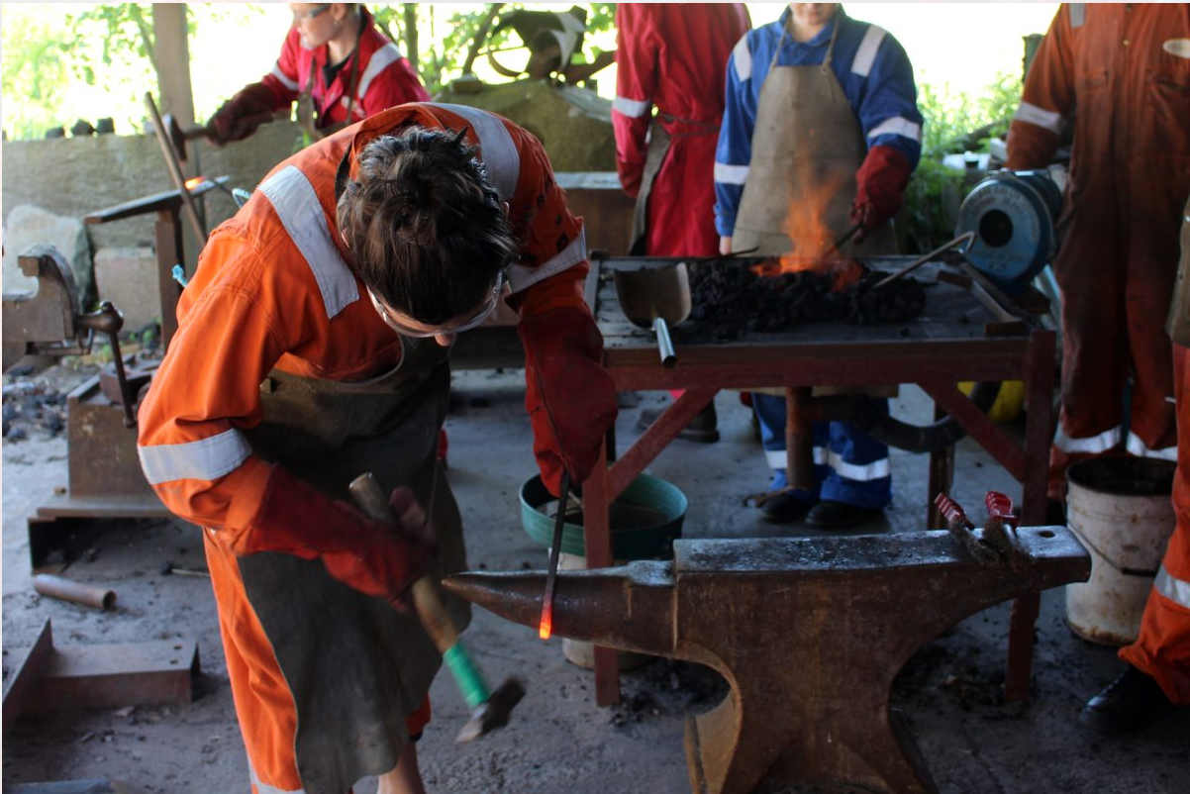

Job Description

As Technical Manager you also have responsibility for:
Facilities
- Manage all aspects of the buildings and workshops ensuring they are safe, well maintained and meet the needs of users as efficiently, safely, and cost-effectively as possible.
- Coordinate technical work plans, maintenance schedules and develop a facilities improvement plan.
- Develop and maintain operational systems and safe systems of work to ensure the smooth and efficient running of the workshop facilities.
- Ensure effective procurement and management of all service contracts and suppliers within agreed budget parameters.
- Maintain, to the highest standard, SSW plant and equipment in both planned, preventative, emergency and reactive maintenance .
- Organise any general repairs and redecoration of the site as necessary and liaise with and supervise third party contractors working to set budget lines.
- Ensure the building and facilities are accessible and adjustments are put in place where possible.
- Be responsible for tools and audio visual equipment lending to residents, upkeep of tools and implementing and maintaining a technical asset register.

Health & Safety
- Oversee the design, implementation, monitoring and review of all Health and Safety controls at SSW and work with an external H&S auditor to ensure compliance and that auditable records are kept in good order.
- Ensure all staff are aware of H&S policy and that training needs are met, recorded and reported in line with statutory compliance requirements including first aid.
- Be responsible for systemic controls, including alarms, fire safety, evacuation procedures and security of the building and ensure contracts are in place to support this.
- Be responsible for statutory compliance across the facilities and related infrastructure including LEV ventilation, lifting equipment and PAT testing.
- Work closely with contractors to oversee completion of work requests.
- Manage near miss and accident reporting and feed the learning of this into action plans and policy updates.
- Responsible for reporting to RIDDOR/ HSE.
Environmental Sustainability
- Responsible to drive forward SSW’s Environmental Action Plan across buildings and facilities.
Lead SSWs carbon management planning and reporting with support from the wider team
- Research the procurement and suitability of materials that are ethical and local where possible as well as work to find more sustainable materials across all processes at SSW.
- Act as SSW’s Green Champion
Oversee responsible waste management across the site

Workshop Pedagogy and Programme Delivery
- Provide process and tool inductions to metal, wood and casting workshops
- Provide basic annual leave cover in ceramics as required
- Deliver basic metal and wood technical guidance for open access users as required and support on technical delivery during particularly busy summer residency periods.
- Manage and support our permanent and visiting technical teams to ensure workloads are manageable and that technical cover meets programme need
- Share their technical knowledge and expertise with the technical team
- Manage technical volunteers and their work plans as required
- Encourage a team ethos and shared investment in the success of the SSW, its mission, its programme and its working culture.

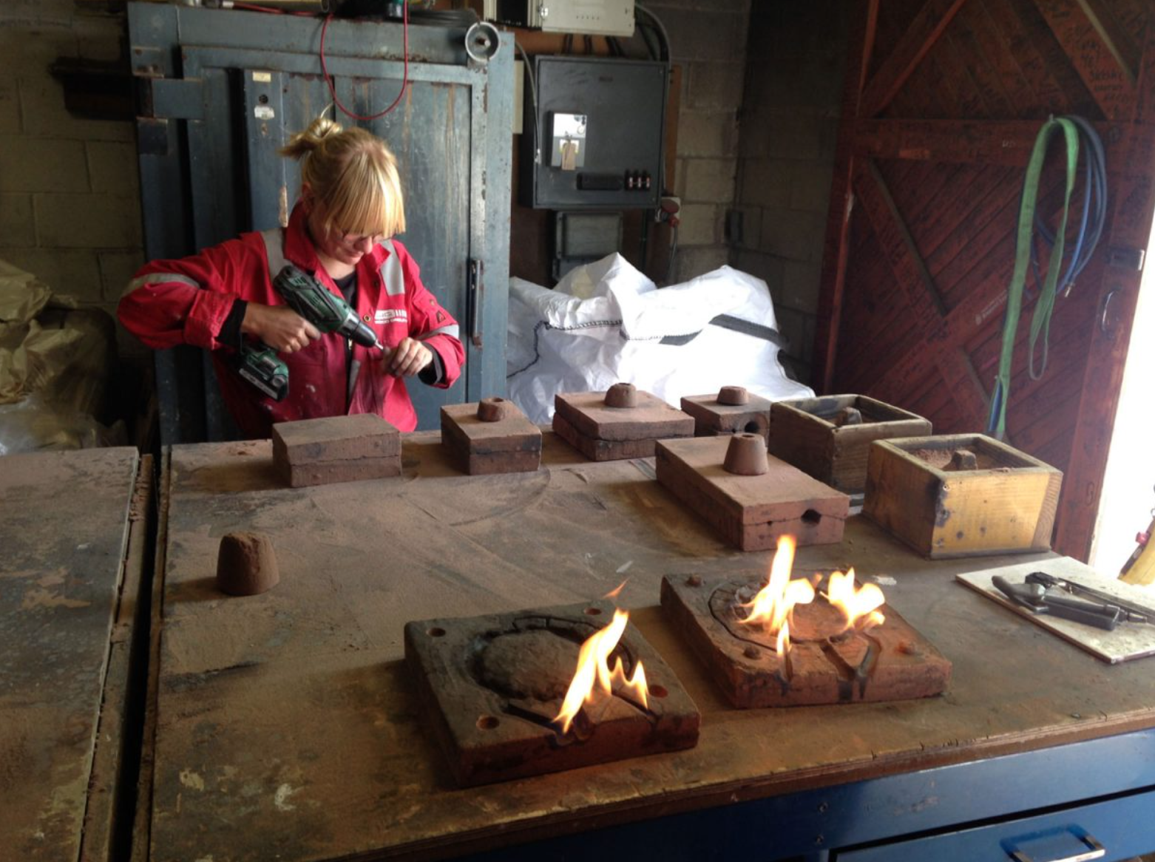
Person Specification
This role requires strong technical knowledge as well as an ability to communicate and collaborate effectively with a wide range of users and colleagues. They will also oversee teaching and learning methods that encourage an inclusive and accessible workshop culture enabling artists and local communities to feel safe, empowered and supported.

Qualifications:
We recognise that experience is formed in multiple ways and as such do not require formal educational requirements for the role. However the candidate should have the below experience and knowledge:
Essential
- Excellent skills in standard metal work, casting and woodworking and the safe use of the machinery, equipment and processes used for these processes.
- Proven ability to share your technical knowledge and skills (including tool and process inductions) with artists and/ or communities from a wide range of backgrounds
- Experience of managing buildings or workshops, ensuring they are safe, well maintained, accessible and meet the needs of users as efficiently, safely and cost-effective as possible
- Experience of designing, implementing, monitoring and reviewing Health and Safety controls
- A proven commitment to environmental sustainability
- Ability to oversee teaching and learning methods that encourage an inclusive and accessible workshop culture for users to feel safe, empowered and supported.
- Experience of working to a strategic plan and commitment to SSW vision and values
- Relevant Health & Safety training and experience
- Ability to work collaboratively and communicate effectively
- Line management experience/ experience of supporting a team
- Excellent computer literacy including confident use of spreadsheets, google work suite and integrated booking systems.
- Good technical problem solver

Desirable

- Experience of developing or delivering an Environmental Action Plan
- Leadership experience
- Experience of working within artists and in community settings
- Certification in COSHH, Risk Assessment delivery, First Aid at Work, IOSH managing safely or equivalents
- Driving License and forklift licence

Through this role we also recognise potential not just experience - if you don't meet all listed criteria but you're passionate about the role and our vision please consider still applying.
Please note that progression within this role is dependent upon meeting key development goals.

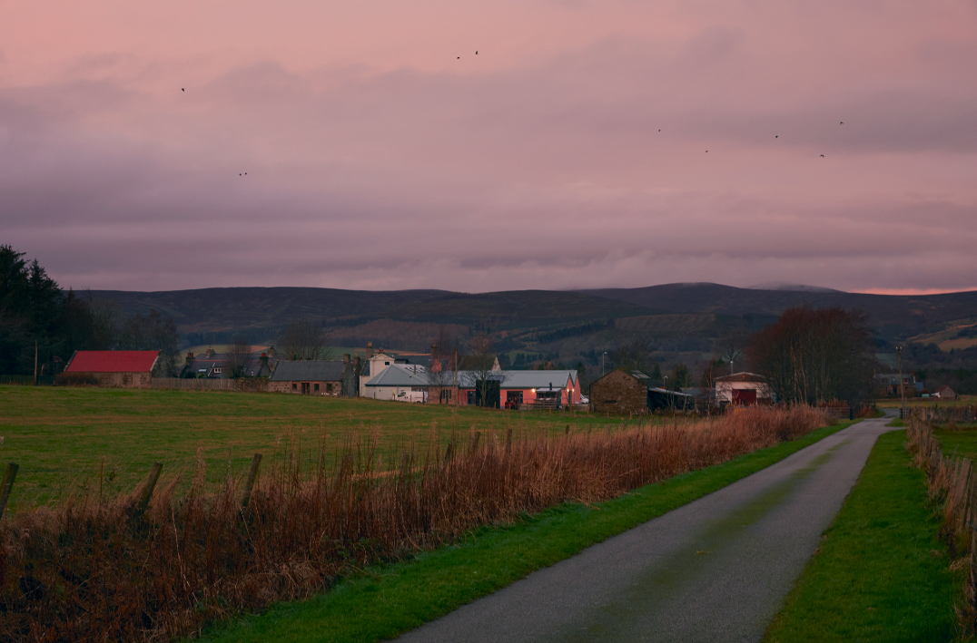

About SSW’s Site and Surrounding Area
SSW is the former village bakery that was developed into Scottish Sculpture Workshop by artist Fred Bushe in 1979. The site includes the recently renovated ceramics studio, artists studio which also hosts the SSW library, a new Community Making Space and a shared office space. Residency accommodation is both on and off site with recently renovated bedrooms, an accessible bedroom and bathroom and an accessible shared kitchen and lounge area supplemented by a sauna built by artist Mari Keski-Korsu. The site also houses a foundry including plaster, sand and ceramic shell casting spaces, a wood and metal workshop and an outdoor forge - research, renovation and redevelopment of these spaces will be a priority area for the Technical Director alongside interim planning for these spaces over the coming years.

SSW is located in Lumsden, a small village in North East Scotland with around 300 inhabitants. In Lumsden, there is a village hall, primary school and car garage with a small shop. The village is surrounded by farmland, moorland and hills, with hills The Buck and Tap O’Noth rising to the North and West, and Bennachie to the East. We are on the main road between towns Alford and Huntly. Lumsden is a 15 minute drive from the Cairngorms National Park, and a short drive to many castles, whisky trails and a wide range of outdoor facilities and pursuits. The North East coast has beautiful beaches and cliff walks, while more locally there are lots of historic sites to explore. The nearest city is Aberdeen. It is approx. one hour’s drive to the south east with train stations within a 20 minute drive of SSW.

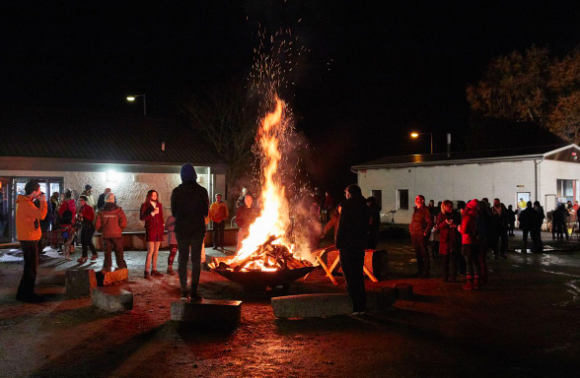

Our Vision, Mission and Values
Vision:
SSW expands the possibilities of what sculpture can be - continuously working towards positive social and environmental change.
Mission:
SSW is embedded in our rural location, with a global outlook and reach. Our artist residencies and locally focussed programmes are set up to rethink and push material and skills based learning, prioritising process and opening up our workshop space as a site where community, creativity and nourishment are a driving force in all that we do.
Values:
Transformative access
Time and space to make is transformative and should be accessible to all. We prioritise access across our site and programmes. We commit to work with partners, communities and professionals to ensure that barriers (physical, environmental and organisational) at SSW are identified and broken down.
Listen, learn and make change
SSW believes that we are all simultaneously learners and teachers and that learning is enabled by working together in a safe and supportive environment. As an organisation we actively work to listen, (un)learn and reimagine what is possible in resistance to dominant narratives.
Collaboration and skill sharing
We work together with collective aims and approaches, valuing the unique perspectives, lived experiences and skills that are held by those we work with. We are here to support artists and our local community and bring together their diverse knowledge and skills to create an open and empowering environment.
Respect and empowerment
Our collective learning makes us powerful! We want to empower each other to shape new visions for the world and believe that this is only possible with respect for ourselves, each other and the environment.

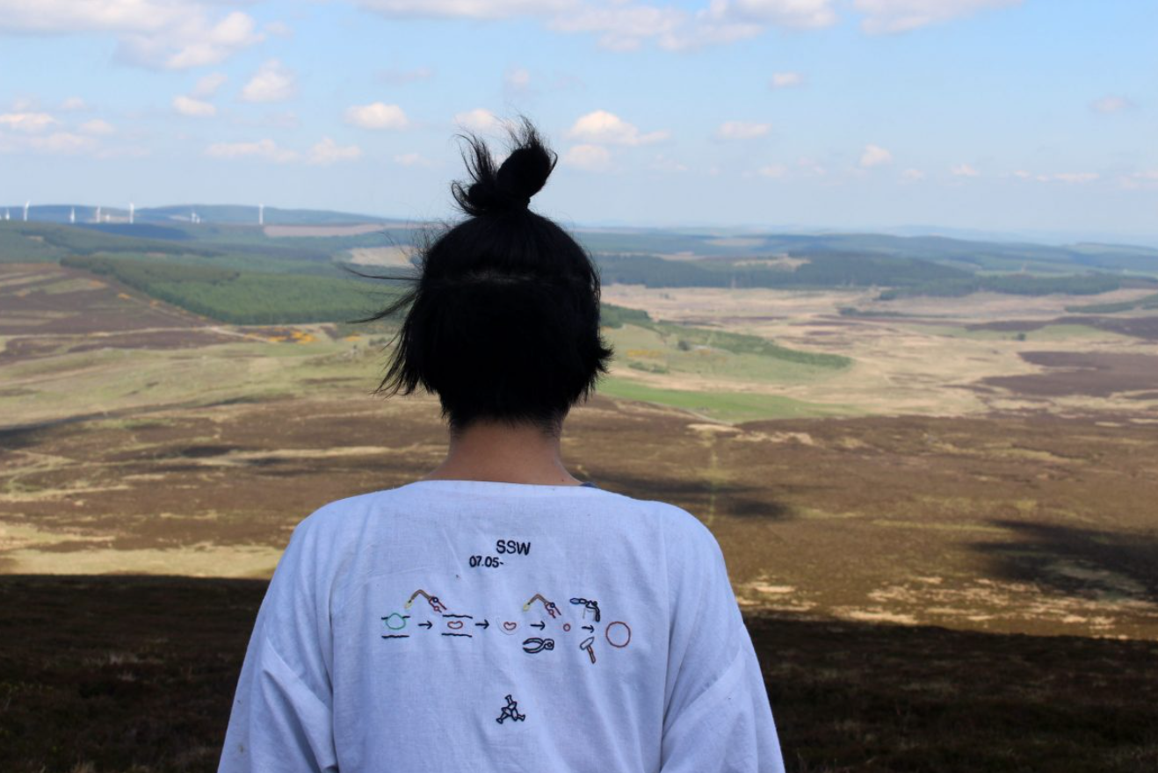
Organisational Aims 2025-2028
High quality, relevant and inclusive programme - To ensure our programme is high quality, relevant to its users and that a diversity of knowledge and lived experience is represented and supported through it.
Democratic and diverse leadership - To support Scotland's arts and culture sector in developing more democratic, robust, diverse and multi-voiced leadership. Actively sharing and developing our co-leadership structure and relevant policy, procedures and organisational learning.
Accessible, inclusive, environmentally sustainable and financially robust organisation - To secure the appropriate resources and expertise needed to support our future focussed workshops that advance the expansion of sculptural practice, foregrounds access and inclusion and ensures environmental and organisational sustainability.

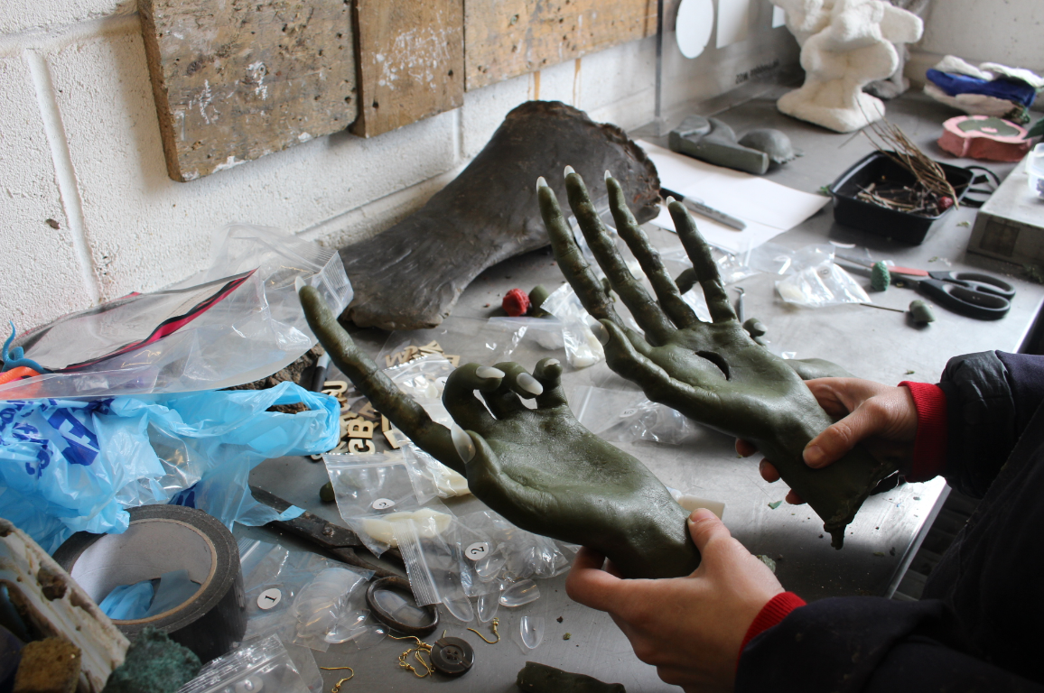

How To Apply and Recruitment Process
Please apply using this online form and by telling us, either in writing of no more than two pages or in a video of up to 5-minutes in length:
- Why you would like to become the Technical Manager at SSW and how you would practically lead our technical operations at SSW to support us in achieving our vision?
- Outline details of your experience and proven track record including how you meet the points outlined in the JD and person spec.
- Share your experience or passion for expanding opportunity and access to craft and sculptural learning
- Earliest available start date
- The names of two referees (only contacted after seeking permission)

Please also include your CV (maximum 2 pages) and complete our Equal Opportunities Monitoring form (this is for monitoring purposes only and will be detached from your application).

Please note that the online form does not save automatically so please work on a separate document and upload once you have completed this.

Applications will be reviewed by a panel who have a diverse range of lived experience made up of SSW’s co-directors and a Board member. We will then contact shortlisted applicants to join us for an interview and a site visit.

Non-discrimination at SSW
At SSW we recognise the historic and ongoing omission of diversity within both the arts and technical fields across Scotland and our role within this. We believe this lack of diversity has led to narrower visions for what sculpture can be and who is able to make and enjoy it. We are committed to a culture of diversity, equity, and inclusion and providing equal opportunities across our organisation. We welcome applications from all backgrounds including, but not limited to, those who identify as from marginalised backgrounds based on any protected characteristic including age, race, gender identity or sexuality, disability or long-term health condition, pregnancy, maternity or marital status, religion or belief, and socio-economic background or class identity.

If you would find it more accessible to complete any part of this application in a different format, please email arts@ssw.org.uk.

