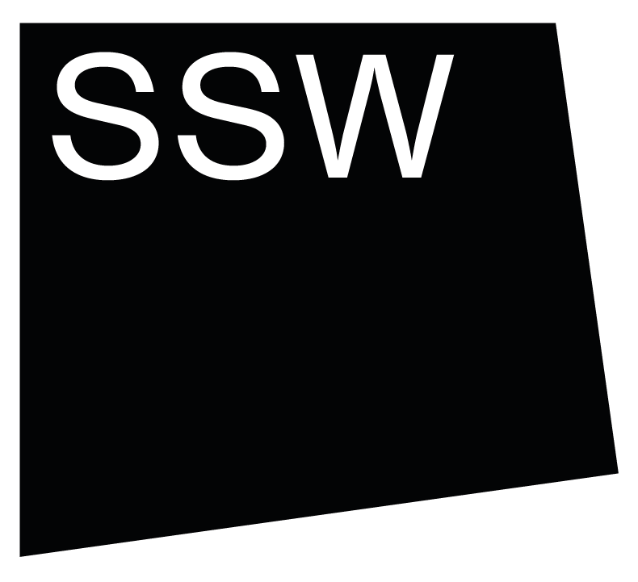

**2025 Group Residency | Frequently Asked Questions**

Scottish Sculpture Workshop

* How do you define who is an artist?
* Can I apply collaboratively with another artist?
* Do you offer a reduced rate if I’m recently graduated?
* I am a student, am I eligible to apply?
* Will the outcome of Creative Scotland's Multi-Year Funding impact Group Residencies at SSW in 2025?
* Do you have accessible accommodation available at SSW?

# **How do you define who is an artist?**

Artists take many forms and do lots of different types of skilled work. This work may focus on a particular process or occasionally have outcomes, such as objects, text, sound, performance, events, group work, walks or film. Artists’ work may also build skills, knowledge, relationships or experiences. We don’t believe you need to have formal arts training to be an artist.

# **Can I apply collaboratively with another artist?**

Yes. We welcome collaborative applications. If you apply collaboratively and are willing to share a bedroom with your collaborator, we offer collaborative residency at 1.5x the residency cost - £720 (incl. VAT) for two people for group residency. If you need your own rooms this is charged at the usual rate.

# **Do you offer a reduced rate if I have recently graduated?**

No. Group Residency is charged at a flat rate of £480 (incl. VAT) for everyone who attends (except collaborative applications - see above).

# **I am a student, am I eligible to apply?**

The residency is not open to applications from artists who will be students at the time of attending the residency. If you are a student when you apply, but will be graduated by the time of the residency this is fine.

This does not apply to PhD students, who are welcome to apply throughout their studies.

# **Will the outcome of Creative Scotland's Multi-Year Funding impact Group Residencies at SSW in 2025?**

Due to the outcomes from Creative Scotland on the Multi-Year Funding (MYF) programme being postponed from October to the end of January 2025, in order to have budget clarity from the Scottish Government, we are having to issue this call out without knowing if SSW will be successful in receiving Multi-Year Funding. To mitigate this we have set the Group Residency deadline for after the scheduled outcome of the MYF process. We feel it is important to maximise the lead in time for artists to make an application and to have enough time to prepare for the residency periods available in 2025, the first of which commences on 27th May 2025.

If SSW does not receive MYF we may need to review the Group Residency programme in 2025, however we will let all applicants and audiences know 1.5 weeks prior to the current deadline. Whatever the outcome we will endeavor to deliver our Group Residency Programme as it forms a core strand to our annual calendar.

# **Do you have accessible accommodation available at SSW?**

From March 2025, following Phase1B of our capital programme, SSW will have one onsite accessible bedroom, bathroom and a self catering kitchen as well as new ramping and landscaping within the courtyard. This has been developed with support of our Capital Access Consultant Tony Heaton OBE. You can also check out our site access information [here](https://www.ssw.org.uk/accessibility/).

If you would like to use this accommodation whilst on residency with us please highlight this within the *Any notes or additional information* section of your application.