**Group Residency 2025 | Application Pack**

Scottish Sculpture Workshop

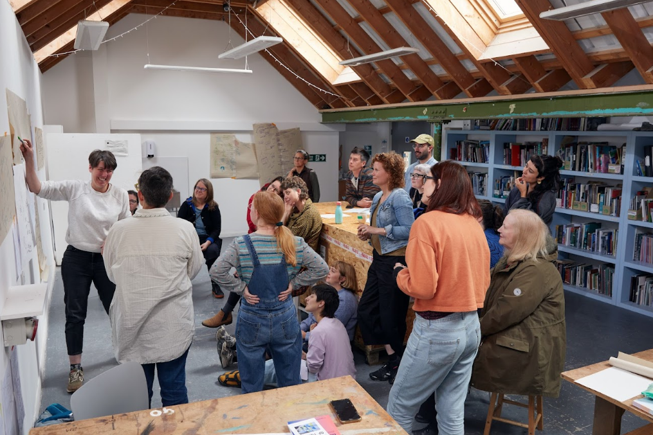

Thank you for your interest in Group Residency at Scottish Sculpture Workshop.

This application pack contains information about the residency, including how to apply. If there is information missing from this pack, or you have any questions, please don’t hesitate to get in touch. You can contact Sam Trotman, Programme & Partnerships Director on [sam@ssw.org.uk](mailto:sam@ssw.org.uk), or phone the office on (+44) 01464 861372.

**Pack contents:**

1. About Group Residency at SSW
2. Who can apply
3. Key dates
4. Costs
5. How to apply
6. Access information
7. Covid-19
8. Visas

# **About Group Residency at SSW**

Group Residency at SSW offers artists dedicated time and support for the development of their practice. Coming together on our rural site in north-east Scotland, up to 6 artists live and work alongside each other for four weeks at a time. We are now inviting applications for three residency groups for the following dates in 2025:

* Group 1: 27 May - 20 June 2025
* Group 2: 18 August - 12 September 2025
* Group 3: 27 October - 21 November 2025

Residency at SSW is experimental, collective and supported by SSW’s skilled team. We have written a little about what to expect whilst [on residency at SSW](https://www.ssw.org.uk/residency/). The combination of access to [facilities](https://www.ssw.org.uk/facilities/) and workshops with peer exchange and learning is unique and offers lots of possibilities for the development of your practice. The residency is particularly suited to artists who;

* want to test out new ideas or directions in their work
* are interested in connecting with materials and processes in our workshops
* are seeking connection with other artists
* value open-ended and experimental approaches to making

Throughout the residency we facilitate a loose structure of optional group activity, including studio sharings, meals, walks, saunas and workshops, to help build connections and conversations between the group.

If you want to fabricate work, have a set outcome or project to work on, [Open Access](https://www.ssw.org.uk/open-access/) is more suitable for your needs.

# **Who can apply**

We welcome applications from artists who are;

- at any stage in their practice

- working in any form/medium/discipline

Artists do not have to have attended any other residencies before, do not need to have undertaken formal arts training (we believe experience is gained in many ways, including through lived experience), or be familiar with workshop environments.

The residency groups are formed carefully to bring together artists with diverse practices, experiences and from different geographic locations. This offers artists a chance to meet others working in different contexts and to make new connections.

# **Key dates**

We are currently inviting applications for three residency groups. Please indicate your availability for the residency dates on your application.

* Group 1: 27 May - 20 June 2025
* Group 2: 18 August - 12 September 2025
* Group 3: 27 October - 21 November 2025

The deadline for applications is **12 February 2025, 12 midday GMT**

We will respond to all applicants in **w/c 24th February 2025**

# **Costs**

Group residency costs £480 (incl. VAT) per artist for a four week residency.   
  
This cost is substantially subsidised by SSW with the support of Creative Scotland’s Regular Funding for Organisations (RFO) to the value of over £2750 per artist.

The residency cost includes accommodation, access to workshop facilities, technical and programme support. The cost does not include materials, consumables, firings, food or travel.

Residency costs are invoiced prior to the residency start date, with materials and consumables invoiced after the residency based on usage. We can support payment plans for artists upon request.

We welcome collaborative applications from two collaborating artists. If the collaborating artists share a bedroom, we will charge this at 1.5x the residency rate - £720 (incl. VAT) for both artists.

We can provide letters of support for invited artists if you would like to seek funding to support your participation in residency at SSW.

In addition to Group Residency, we also offer a range of partnership residencies which are funded. You can find out more about these on [our residency page](https://www.ssw.org.uk/residency/).

# **How to apply**

We want your experience of applying to Group Residency at SSW to be straightforward and accessible. Please apply for Group Residency in a format that is comfortable for you - writing, voice memo/audio or video. We don’t have a preference and will only consider the content of the application, not its production.

Please contact us if you have any questions, if you have technical difficulties or you have access requirements that we can support you with in the application process.

Get in touch with us before the deadline if you are struggling to submit on time - extensions may be possible on a case-by-case basis, providing this is arranged in advance.

The application form:

* We accept applications [**via the online form**](https://scottishsculptureworkshop.wufoo.com/forms/2025-group-residency-application-form). If for access reasons you would prefer to submit via email, please download the application form [from the website](https://www.ssw.org.uk/group-residency/) and send this, completed, to [sam@ssw.org.uk](mailto:sam@ssw.org.uk), before the deadline.
* If you are applying by audio or video please provide links to these files in the application form with any passwords.
* If there is another format that would support you to make your best application then please get in touch via the details above.

**The questions:**

1. Tell us about what interests and excites you in your work.  
   1. Please try to be concise and use uncomplicated language.
   2. We want to hear what you are thinking about or exploring through your work.
   3. We are not looking for a CV or career history here, rather to understand what you are doing and what motivates your practice.
2. Why do you want to come on Group Residency at SSW?   
   1. Please use clear and uncomplicated language
   2. Try to be specific - why do you want to participate in Group Residency? Why do you want to come on residency at SSW?
   3. What can you bring to the group setting and how would you benefit from this?
   4. You might find it helpful to read about [residency at SSW](https://www.ssw.org.uk/residency/), look at [our facilities](https://www.ssw.org.uk/facilities/) and ongoing [projects](https://www.ssw.org.uk/fullscreen/projects/) and connect with [our mission and values](https://www.ssw.org.uk/about/).
3. Provide examples of your work to support your application.
   1. This does not need to be recent work if you have had a break from your practice, but it should give us an opportunity to understand your practice better.
   2. This can be provided in whatever format is most convenient for you.
   3. Please be mindful that we have a limited time allocated to each application and can’t watch whole films or listen to complete audio recordings if these are longer than 2 minutes.
   4. Please provide a maximum of 6 images, 3 pieces of text or 2 links to external media or websites (or a combination of these). We will not be able to look at all pages on a website so please direct us to the content you want us to see.

**The selection process:**

Two members of the team at SSW will read through and assess all applications. Applications will be shortlisted on the following criteria:

|  |  |
| --- | --- |
| Criteria | Weighting |
| Demonstration of how group residency would support the ongoing development of the artists’ practice | 40% |
| Reasons given for attending residency at SSW specifically in particular the value of Group context | 40% |
| Links and connections between reasons given and artists’ existing work and interests | 20% |
| Total | 100% |

Following shortlisting to the above criteria, we will take into consideration practicalities, such as your availability, capacities in accommodation and facilities and artist location etc.

From the shortlist we will invite between 15-18 artists to join the three groups.

**Feedback**

All applicants will be notified of the outcome of their application by **w/c 24th February 2025.** We will offer short overview feedback for shortlisted but unsuccessful applicants. This must be requested by **3rd March 2025.**

# **6. Access information**

We welcome access riders and/or informal conversations prior to and throughout the residency about what you need to work and live comfortably on site at SSW.

We understand ‘access’ to be what you need to be able to participate in a residency comfortably and as safely as possible. These access needs may be physical, for example different heights of workstations or access to quiet space. They may be cultural, for example connections with different groups or organisations in the area, or a space for worship. Needs may include communication requirements (email / text/ phone / hardcopy), translated documents or space for your family (bio/chosen), an ally, support worker or travel buddy to stay. These are just a few examples and we encourage you to get in touch in the first instance before you apply, to discuss what we can put in place to support your participation in residency here.

Contact Sam on [sam@ssw.org.uk](mailto:sam@ssw.org.uk) / (+44) 01464 861372 with any questions or to discuss your needs.

# **7. Visas**

We advise all artists travelling from outwith the UK to check current guidance on visas before travelling to SSW. SSW is not liable for any costs related to visas, including if you are denied entry to the country and we advise you check out available resources to determine if you will need a visa.

As per current guidance (May 2022) creative workers including ‘professional artists’ from non-visa national countries can travel to the UK for artists’ residency without requiring a visa. If you plan to undertake paid work while here on residency we advise you check current guidance to see if this is legally permitted. We cannot provide visa sponsorship for artists coming on Group Residency at this time.

Visa nationals are required to apply for a UK visitor visa to attend artists’ residency. There is more information and resources on artists’ visa requirements in the UK on Arts Infopoint UK [here](https://artsinfopointuk.com/coming-uk-where-do-i-start).