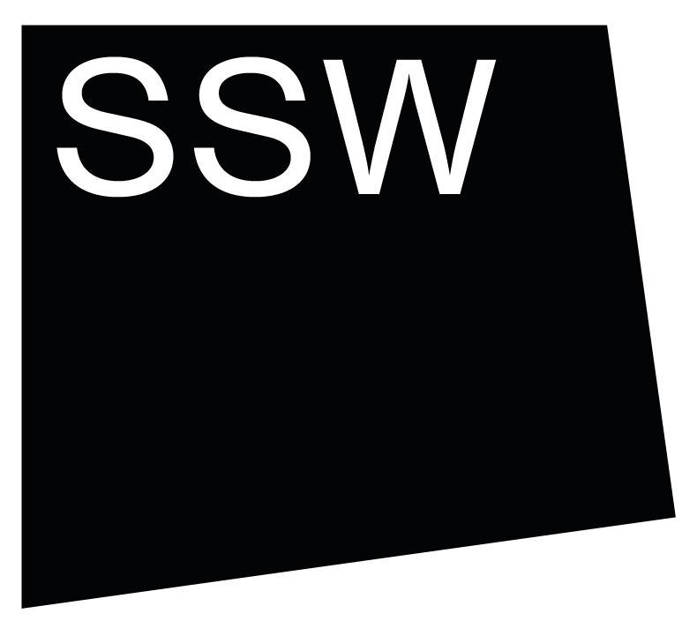


Scottish Sculpture Workshop

Group Residency 2026
Application Questions

Deadline for applications: 23 January 2026, midday GMT

This is a copy of the questions on the application form for Group Residency 2026. You can use this to prepare your answers before submitting them through the online form.
If, for access reasons, you would prefer not to submit through the online form, complete the questions in this document and send it by email to arts@ssw.org.uk before the deadline, with ‘Group Residency Application’ in the subject line.
Please also complete the separate Equalities, Diversity and Inclusion (EDI) form through the online form or the separate EDI form document and send it by email to arts@ssw.org.uk.
Please contact us at SSW if you have any questions about this residency, if you have technical difficulties or you have access requirements that we can support you with in the application process.

QUESTIONS
* = compulsory questions

Name*
(First & last)

What are your pronouns?*
Tell us how you like to be referred to, for example they/them, he/him, she/her or any others

Email*

Phone number*

How do you prefer to be contacted?*
Email
Phone
Either is fine
Where are you based?*

Are you applying collaboratively?*
Yes
No

If yes, What’s your collaborators name?

If yes, What are your collaborators' pronouns?

What are your preferred dates? *
Please select all the blocks you are available for, not just a preferred date.

Group Residency 1: 29 June - 24 July 2026
Group Residency 2: 3 August - 28 August 2026
Group Residency 3: 21 September - 16 October 2026

Tell us about what interests and excites you in your work.*
(400 words / 2:00 recording)

- Please use uncomplicated language.
- We want to hear what you are thinking about or exploring through your work.
- We are not looking for a CV or career history here, rather to understand what you are doing and what motivates your practice.
- For audio/video please paste a link and any passwords.

Why do you want to come on Group Residency at SSW?*
(400 words / 2:00 recording)

- Please use uncomplicated language.
- Try to be specific - why do you want to participate in Group Residency?
- Why do you want to come on residency at SSW?
- What can you bring to the Group setting and how would you benefit from this?
- You might find it helpful to visit our website to understand what we offer.
- For audio/video please paste a link and any passwords.

Any notes or additional information.
This will not be used in the selection process.
- This is a free box for any additional, practical information about your application. Feel free to leave it blank if there is nothing practical we need to know at this stage.
- If you would like to share any access requirements at this point, please do so here.
- If you would like to discuss access at SSW please contact Anna by emailing arts@ssw.org.uk or calling the office on +44 (0) 1464 861372.

Examples of your work.

- Please share some examples of your work to support your application.
- Please compile documentation into a single file (pdf, word doc, etc)
- Your compiled documentation can be any combination of:
- up to 6 images
- up to 2 texts
- up to 2 webpages
- This does not need to be recent work if you have had a break from your practice, but it should help us understand your practice better.
- Please be mindful that the panel has limited time allocated to each application and will not be able to listen to whole films or audio recordings if they are longer than 2 minutes.

Link 1:
Password:
Link 2:
Password:

How did you hear about Group Residency?*

Would you like to receive our newsletter? .*
We send around one per month, with opportunities, events and news

Yes
I’m already signed up
No thanks

Equalities Monitoring
Please complete our Equalities, Diversity & Inclusion (EDI) questionnaire.
Click the link and it will open in a new tab:
Equalities, Diversity & Inclusion (EDI) questionnaire

Please confirm you have completed the Equalities, Diversity & Inclusion (EDI) questionnaire*

Privacy Policy

SSW will use the information you provide in this form to contact you and provide you with updates and marketing if agreed. We will share the application questions with the selection panel, while all other details will be held confidentially by SSW. We treat your information with respect. For more information about our privacy practices please visit our website: http://www.ssw.org.uk/privacy-policy

* I agree you may process my information in line with these terms

Thank you for completing an application for Group Residency.
Before pasting into the online form or sending this form via email, please make sure to read through your application thoroughly.

If you submit by email we will respond to your application to confirm we have received it.

