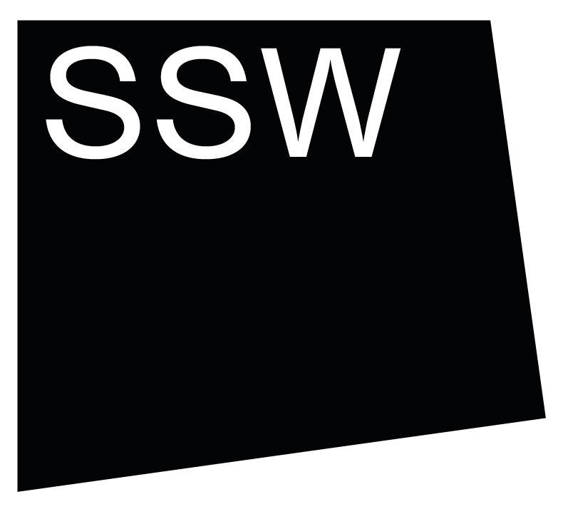


Scottish Sculpture Workshop

Group Residency 2026
Frequently Asked Questions

- How do you define who is an artist?
- Can I apply collaboratively with another artist?
- Do you offer a reduced rate if I’m recently graduated?
- I am a student, am I eligible to apply?
- Do you have accessible accommodation available at SSW?
- What workshop facilities can I use on Group Residency?
- Can I apply to Group Residency if I have previously applied or undertaken a residency at SSW?

How do you define who is an artist?

Artists take many forms and do lots of different types of skilled work. This work may focus on a particular process or occasionally have outcomes, such as objects, text, sound, performance, events, group work, walks or film. Artists’ work may also build skills, knowledge, relationships or experiences. We don’t believe you need to have formal arts training to be an artist.

Can I apply collaboratively with another artist?

Yes. We welcome collaborative applications. If you apply collaboratively and are willing to share a bedroom with your collaborator, we offer collaborative residency at 1.5x the residency cost - £720 (incl. VAT) for two people for group residency. If you need your own rooms this is charged at the usual rate.

Do you offer a reduced rate if I have recently graduated?

No. Group Residency is charged at a flat rate of £480 (incl. VAT) for everyone who attends (except collaborative applications - see above).

I am a student, am I eligible to apply?

The residency is not open to applications from artists who will be students at the time of attending the residency. If you are a student when you apply but will be graduated by the time of the residency then you can apply.

This does not apply to PhD students, who are welcome to apply throughout their studies.

Do you have accessible accommodation available at SSW?

SSW has one onsite level access double bedroom with an ensuite toilet and shower room, with access to a communal self-catering kitchen via ramping.

If you would like to use this accommodation whilst on residency with us please highlight this within the Any notes or additional information section of your application.
If you would like to discuss access at SSW please contact Anna by emailing arts@ssw.org.uk or calling the office on +44 (0) 1464 861372.

What workshop facilities can I use on Group Residency?
As part of Group Residency we programme a series of inductions and intros to our facilities including ceramics, metal fabrication, blacksmithing and stonework, as well as social spaces to encourage connection, including sauna, artists sharings, film nights, walks and shared meals.

Can I apply to Group Residency if I have previously applied or undertaken a residency at SSW?
Yes. If you have applied to Group Residency previously you are welcome to apply again.
If you have previously undertaken a residency at SSW, please make clear in your application why you would like to return.

