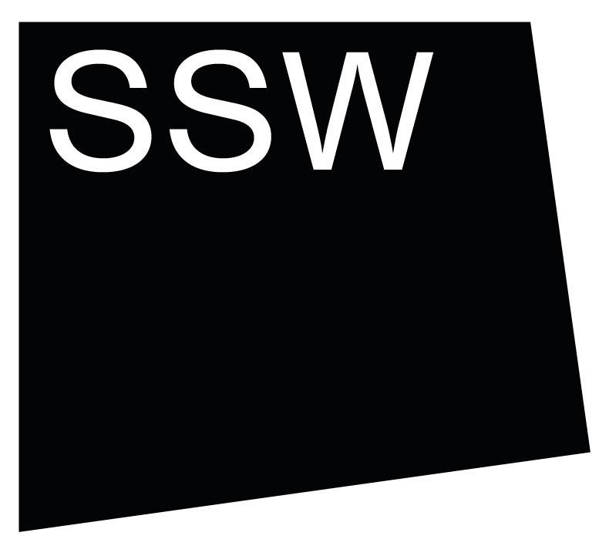


Scottish Sculpture Workshop

Group Residency 2026
Application Pack

Thank you for your interest in Group Residency at Scottish Sculpture Workshop.

This application pack contains information about the residency, including how to apply. If there is information missing from this pack, or you have any questions, please don’t hesitate to get in touch. You can contact Anna Lomas, Programme Producer on arts@ssw.org.uk, or phone the office on +44 (0)1464 861372.

Pack contents:

- About Group Residency at SSW
- Who can apply
- Key dates
- Costs
- How to apply
- Access information
- Visas

About Group Residency at SSW

Group Residency at SSW offers artists dedicated time and support for the development of their practice. Coming together on our rural site in north-east Scotland, up to 6 artists live and work alongside each other for four weeks at a time. We are now inviting applications for three residency groups for the following dates in 2026:

- Group Residency 1: 29 June - 24 July 2026
- Group Residency 2: 3 August - 28 August 2026
- Group Residency 3: 21 September - 16 October 2026

Residency at SSW is experimental, collective and supported by SSW’s skilled team. We have written a little about what to expect whilst on residency at SSW. The combination of access to facilities and workshops with peer exchange and learning is unique and offers lots of possibilities for the development of your practice. The residency is particularly suited to artists who;

- want to test out new ideas or directions in their work
- are interested in connecting with materials and processes in our workshops
- are seeking connection with other artists
- value open-ended and experimental approaches to making

Throughout the residency we facilitate a loose structure of optional group activity, including studio sharings, meals, walks, saunas and workshops, to help build connections and conversations between the group.

If you want to fabricate work, have a set outcome or project to work on, Open Access is more suitable for your needs.

Who can apply

We welcome applications from artists who are;

- at any stage in their practice
- working in any form/medium/discipline

Artists do not have to have attended any other residencies before, do not need to have undertaken formal arts training (we believe experience is gained in many ways, including through lived experience), or be familiar with workshop environments.

The residency groups are formed carefully to bring together artists with diverse practices, experiences and from different geographic locations. This offers artists a chance to meet others working in different contexts and to make new connections.

Key dates

We are currently inviting applications for three residency groups. Please indicate your availability for the residency dates on your application.

- Group Residency 1: 29 June - 24 July 2026
- Group Residency 2: 3 August - 28 August 2026
- Group Residency 3: 21 September - 16 October 2026

The deadline for applications:
23 January 2026, 12 midday GMT

We will respond to all applicants: w/c 16 February 2026

Costs

Group residency costs £480 (incl. VAT) per artist for a four week residency.
This cost is substantially subsidised by SSW with the support of Creative Scotland’s Multi-Year Funding Programme to the value of over £3000 per artist.

The residency cost includes accommodation, access to workshop facilities, technical and programme support. The cost does not include materials, consumables, firings, food or travel.

Residency costs are invoiced prior to the residency start date, with materials and consumables invoiced after the residency based on usage. We can support payment plans for artists upon request.

We welcome joint applications from two collaborating artists. If the collaborating artists share a bedroom, we will charge this at 1.5x the residency rate - £720 (incl. VAT) for both artists.
We can provide letters of support for invited artists if you would like to seek funding to support your participation in residency at SSW.

In addition to Group Residency, we also offer a range of partnership residencies which are funded. You can find out more about these on our residency page.

How to apply
We want your experience of applying to Group Residency at SSW to be straightforward and accessible. Please apply using the format that feels most comfortable for you, either text, audio or video. We have no preference and will only evaluate the content of each application, not its production.
Please contact us if you have any questions, if you have technical difficulties or you have access requirements that we can support you with in the application process.
Submit your application before the deadline. Get in touch with us by emailing arts@ssw.org.uk if you are having problems submitting on time.
When you finish submitting your application you will receive a confirmation message.

The application form:
- We accept applications via this online form:
2026 Group Residency application form
If, for access reasons, you would prefer to not submit through the online form, there is a .doc and .pdf copy of the questions available via the website. Once complete, email the completed application to arts@ssw.org.uk with “Group Residency Application” in the subject, before the deadline.

- Unfortunately the online form does not save as you are filling it in, so we advise you write and save your answers separately, then copy and paste your answers or recording links into the form in case you lose your connection or refresh the page while you are filling it in.

- If you are applying by audio or video please provide links to these files in the application form with any passwords.

- If there is another format that would support you to do your best application then please get in touch via arts@ssw.org.uk and we will work with you to try and make it possible.

The questions:

- Tell us about what interests and excites you in your work.
  - Please try to be concise and use uncomplicated language.
  - We want to hear what you are thinking about or exploring through your work.
  - We are not looking for a CV or career history here, rather to understand what you are doing and what motivates your practice.

- Why do you want to come on Group Residency at SSW?
  - Please use clear and uncomplicated language.
  - Try to be specific - why do you want to participate in Group Residency? Why do you want to come on residency at SSW?
  - What can you bring to the group setting and how would you benefit from this?
  - You might find it helpful to read about residency at SSW, look at our facilities and connect with our mission and values.

- Provide examples of your work to support your application.

  - Please compile documentation into a single file (pdf, word doc, etc)
  - Your compiled documentation can be any combination of:

- up to 6 images
- up to 2 texts
- up to 2 webpages
  - This does not need to be recent work if you have had a break from your practice, but it should help us understand your practice better.
  - Please be mindful that the panel has limited time allocated to each application and will not be able to listen to whole films or audio recordings if they are longer than 2 minutes.

Before you make your application we would advise reading our 2026 Group Residency FAQs.

The selection process:

SSW team members will read through and assess all applications. Applications will be shortlisted on the following criteria:

Criteria | Weighting
Demonstration of how group residency would support the ongoing development of the artists’ practice | 40%
Reasons given for attending residency at SSW, in particular the value of Group context | 40%
Links and connections between reasons given and artists’ existing work and interests | 20%
Total | 100%

We will also take into consideration practicalities, such as your availability, capacities in accommodation and facilities, and artist location etc.

We will invite up to 18 artists to join the three groups.
Feedback
All applicants will be notified of the outcome of their application w/c 16 February 2026.
We are only able to provide short overview feedback for shortlisted applicants. We will let you know if your application was shortlisted and feedback should be requested by 2 March 2026.

6. Access information
We welcome access riders and/or informal conversations prior to and throughout the residency about what you need to work and live comfortably on site at SSW.

We understand ‘access’ to be what you need to be able to participate in a residency comfortably and as safely as possible. These access needs may be physical, for example different heights of workstations or access to quiet space. They may be cultural, for example connections with different groups or organisations in the area, or a space for worship. Needs may include communication requirements (email / text/ phone / hardcopy), translated documents or space for your family (bio/chosen), an ally, support worker or travel buddy to stay. These are just a few examples and we encourage you to get in touch in the first instance before you apply, to discuss what we can put in place to support your participation in residency here. SSW Accessibility information can be found here, please note this will be updated at the start of 2026.

Contact Anna Lomas, Programme Producer by emailing arts@ssw.org.uk or call the office on +44 (0) 1464 861372 with any questions or to discuss your needs.

Visas

We advise all artists travelling from outwith the UK to check current guidance on visas before travelling to SSW. As per current guidance (2025) artists who are Non-Visa Nationals and undertaking unpaid work can enter the UK as standard visitors for up to 6 months.
For more information on visas for artists visiting the UK, please visit Arts Infopoint UK.
SSW is not liable for any costs related to visas, including if you are denied entry to the country and we advise you to check out available resources to determine if you will need a visa.

