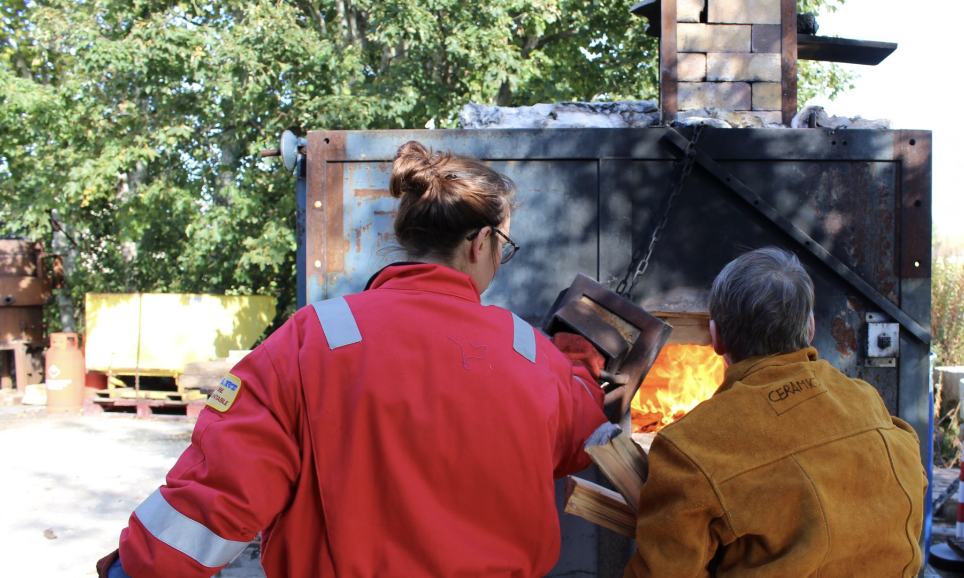
Image credit: SSW

Summer Technician
Scottish Sculpture Workshop
Job Pack

Deadline for Applications: Midday, Friday 27th March 2026
Interview: Friday 3rd April
Applicants notified of the outcome: w/c 6th April
Commencement of Contract: June 2026
End of Contract: September 2026
If you require any access or technical support with the application process, please contact arts@ssw.org.uk
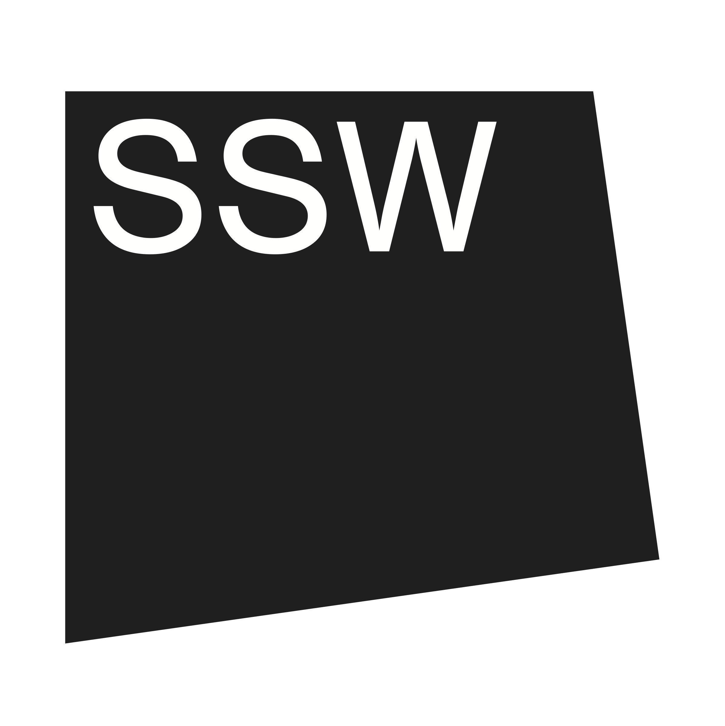
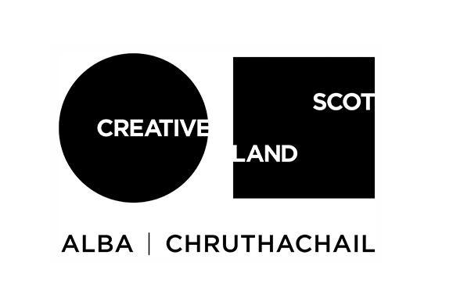
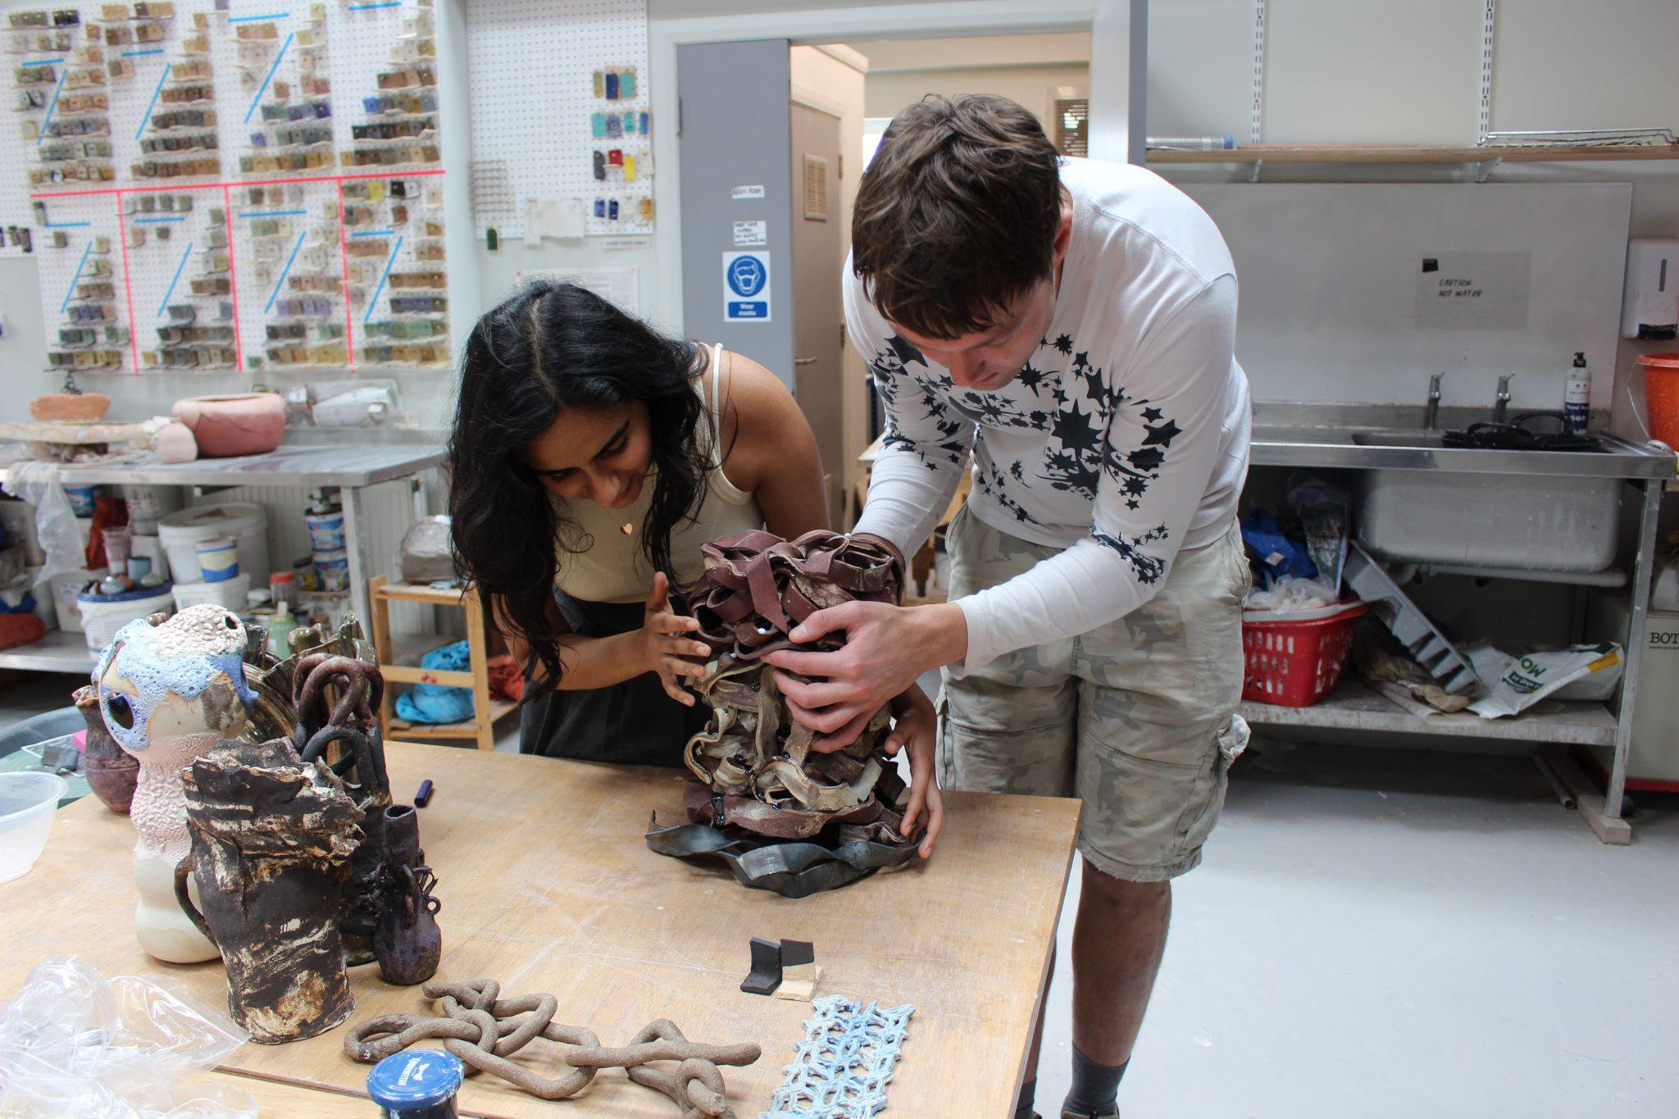
Image credit: SSW
About the Role

Job Title: Summer Technician
Salary: £28,000 - £32,000 (pro-rata) depending on experience, valid certifications and training
Pension: 5% pension contribution
Contract: 0.6 (3 days/ 22.5 hrs per week) fixed term for 4 months may include working weekends and evenings as required
Responsible to: Technical Director
Holiday: 16 days (in 4 months this is equivalent to 5.5 days during this contract)
Training: SSW will provide inductions, workshop and H&S orientation and EDI and Gender Expression/ Identity training in advance of commencement of working with artists
TOIL: Overtime is paid through TOIL which must be outlined and agreed in advance with line managers.
Place of work: SSW, Lumsden, Aberdeenshire, Scotland. It is a requirement to be onsite to undertake this role.

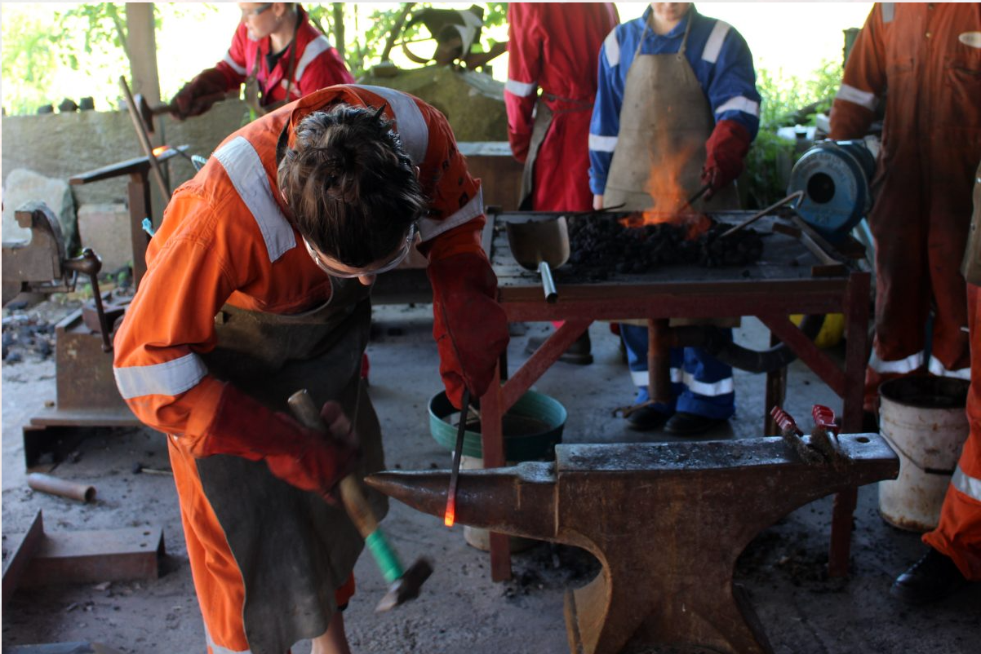
Image credit: SSW

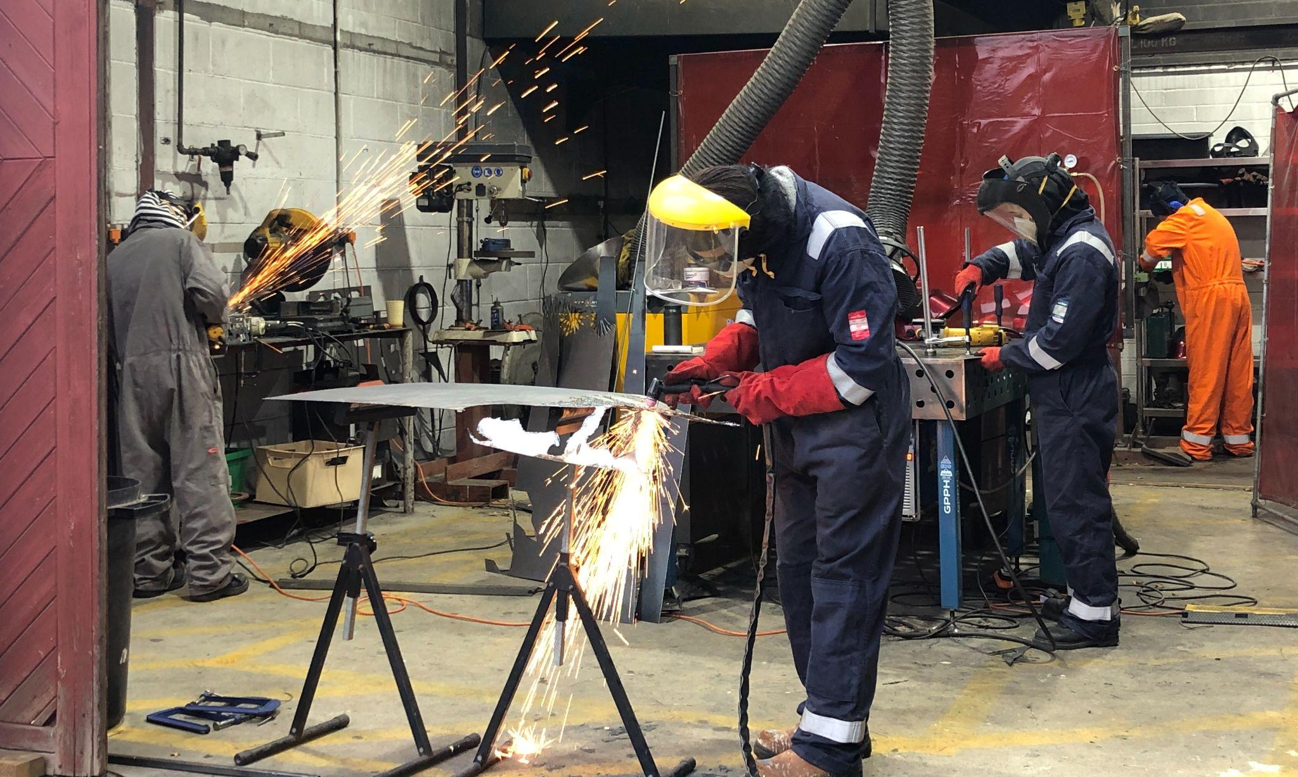
Image credit: SSW

Job Overview
The Summer Technician is a 3 day a week, fixed-term role set up to support the SSW technical team, artists and community members during our busy Summer programme. They will provide practical and technical assistance to artists, community learners and other SSW users, and ensure workshops operate safely, efficiently, and to a high professional standard.

Working primarily across our casting and metal workshops as well as some support in ceramics, the Summer Technician will assist the technical team with the preparation, maintenance, and supervision of equipment, materials, and studio spaces. They will help facilitate a wide range of activity to support artists on residency/ open access and local residents in our Community Making Space.
They should have a good level of practical experience in casting, plaster mould-making, and metal fabrication processes. They will be confident in providing technical guidance and working closely with artists, supporting the development of projects and assisting in learning new skills. This may include giving demonstrations, providing inductions or making samples.
The successful candidate will be driven by SSW’s mission to expand the possibility of what sculpture can be and who is able to make and enjoy it. They will work with and support artists from a wide range of disciplines, backgrounds and lived experiences. They should be aware of the multiple barriers that workshops can present and be active in breaking these down, working alongside the wider SSW team.
The role requires a proactive and adaptable approach, with an understanding of workshop processes and safe working practices. The successful candidate will contribute to maintaining a safe, organised, and welcoming environment, adhering to current health and safety guidance and SSW procedures at all times.

They should be warm, approachable and committed to holding an accessible environment for artists, community members and staff. They should be a strong communicator and have a can-do attitude to supporting artists. They should be able to work closely with colleagues as well as independently and have experience of working within the contemporary arts, craft or design contexts.

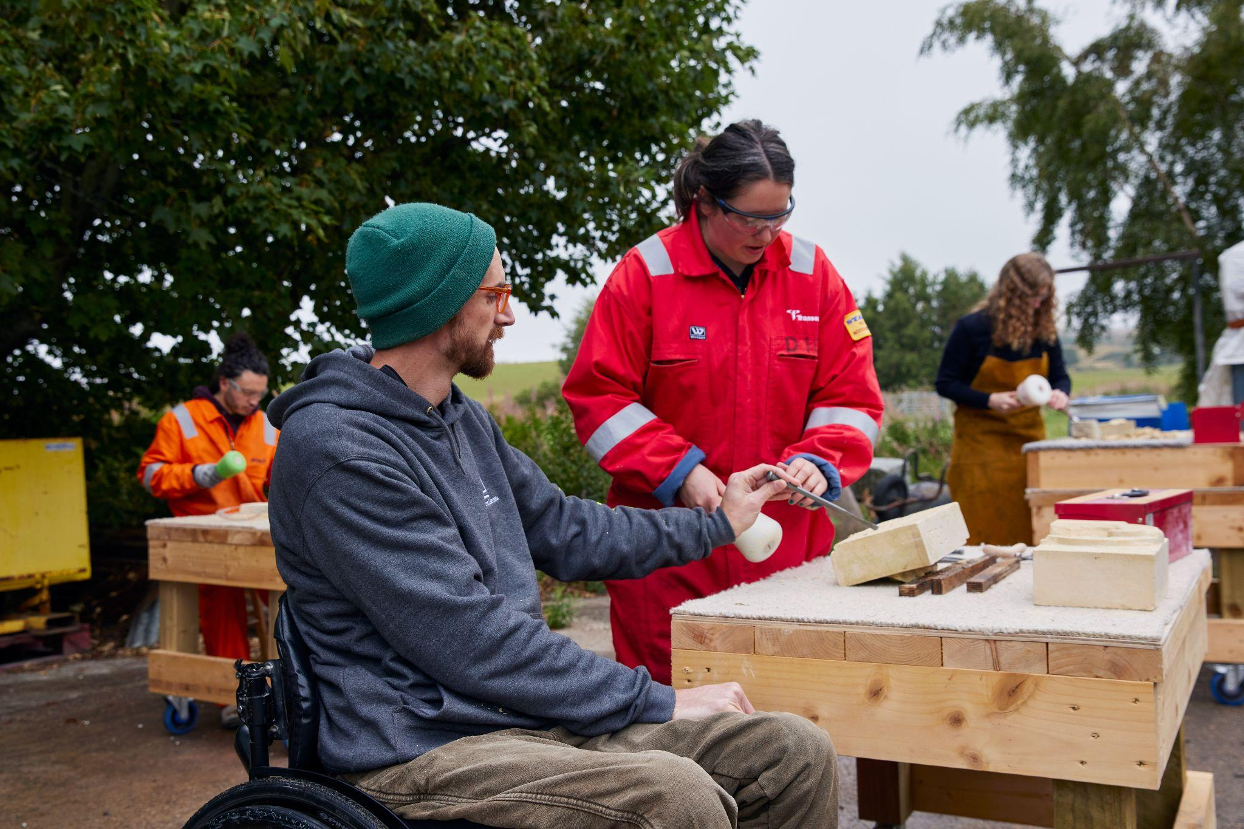
Image credit: Felicity Crawshaw
Job Description

The Summer Technician will work across 3 core areas of SSW including:

Programme & Workshop Delivery

- Provide process and tool inductions primarily across all casting, metal workshops with some support in ceramics
- Deliver casting, metal and ceramics technical guidance for artists
- Provide practical support and technical guidance to artists and ceramic users to achieve their ideas and learn a range of processes and outcomes across our workshops.
- Provide support to our permanent and freelance technical teams to ensure workloads are manageable and that technical cover meets the summer programme need
- Join residency sharings and activities
- Support in the setting up of Community Making Space sessions
- Facilitate a welcoming, inclusive, and professional environment
- Provide basic annual leave cover in casting, metal and ceramics as required

Facilities

- Assist in the upkeep of SSW facilities and site ensuring the workshops and associated spaces are in good working order
- Make sure materials are recorded, stored and disposed of safely and appropriately
- Assist the Ceramics Technician in kiln loading, unloading, firing, and kiln shelf maintenance
- Assistant the team to ensure plant and equipment is maintained to the highest standard through planned, preventative, emergency, and responsive maintenance
- Prepare the site for relevant residency and Community Making Space activity

Health & Safety

- Support the implementation of Health and Safety procedures through workshop inductions and safe systems of work
- Support the Technical Director in ensuring statutory compliance across SSW’s facilities and related infrastructure
- Ensure everyone who uses the workshop facilities has undertaken Health and Safety and studio inductions, tool and process inductions and are informed of protocol of the SSW site
- Feedback information vital for the review of risk assessments, COSHH as well as tool and process inductions
- Ensure health & safety policies and best practice are followed at all times

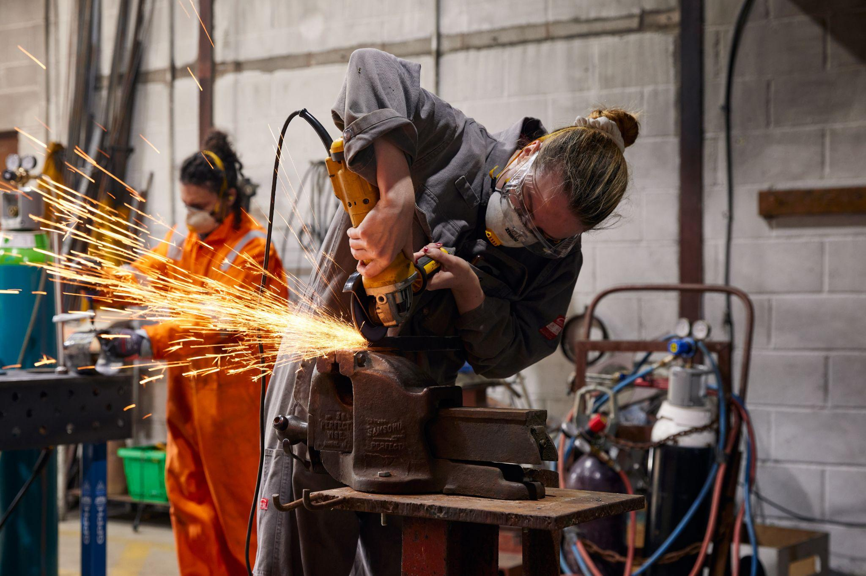
Image credit: Felicity Crawshaw

Person Specification
This role requires strong technical knowledge as well as an ability to communicate and collaborate effectively with a wide range of artists and colleagues. They will also deliver inductions and support an inclusive and accessible workshop culture enabling artists and local communities to feel safe, empowered and supported.

Qualifications
We recognise that experience is formed in multiple ways and as such do not require formal educational requirements for the role. However the candidate should have the below experience and knowledge:
Essential
- Proven ability to share your technical knowledge and skills (including tool and process inductions) with artists and/ or communities from a wide range of backgrounds across casting, metal, and ceramics
- Strong knowledge of casting, metal, wood and ceramics machinery, equipment and processes
- Experience of ensuring buildings or workshops are safe, well maintained, accessible and meet the needs of users
- Excellent organisational and communication skills
- A passion for making, and an ability to share this passion with others
- Ability to work collaboratively in a small team
- Good technical problem solver and creative thinker who can support artists with a range of technical abilities
- A genuine understanding of workshop barriers and a commitment to breaking these down
- Excellent knowledge of workshop health and safety procedures
- Holistic approach to learning and teaching
- Self-motivated, proactive with a friendly and caring attitude
- Excellent computer literacy including confident use of spreadsheet and google suite
- Contribute to a team ethos and shared investment in the success of the SSW, its mission, its programme and its working culture.

Desirable

- Experience working with artists or cultural organisations
- Familiarity with public funding or reporting requirements
- First Aid / Health & Safety training
- Relative certifications ie Abrasive wheels, Hot works, Manual handling
- Confidence in ordering materials and communicating with suppliers
- Driving license

We recognise that the successful candidate may not have equal knowledge and expertise across all material processes at SSW. However they should be competent, technically minded and able to learn quickly. In this role we also recognise potential not just experience - if you don't meet all listed criteria but you're passionate about the role and our vision please consider still applying.

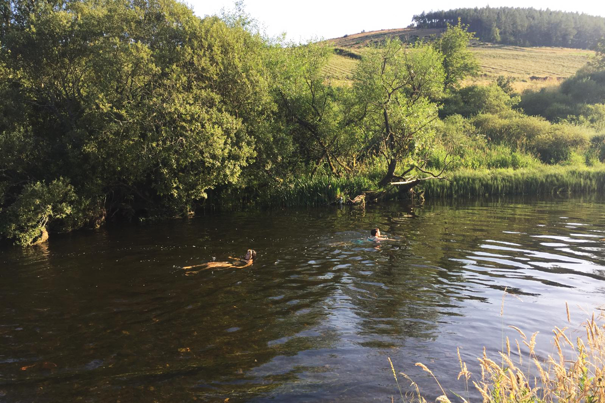
Image credit: Camille Biddell

About SSW’s Site and Surrounding Area
SSW is the former village bakery that was developed into Scottish Sculpture Workshop by artist Fred Bushe in 1979. The site includes the recently renovated ceramics studio, artists studio which also hosts the SSW library, a new Community Making Space and a shared office space. Residency accommodation is both on and off site with recently renovated bedrooms, an accessible bedroom and bathroom and an accessible shared kitchen and lounge area supplemented by a sauna built by artist Mari Keski-Korsu. The site also houses a metal fabrication workshop including plaster and casting space, a metal workshop and an outdoor forge and kilns.

SSW is located in Lumsden, a small village in North East Scotland with around 300 inhabitants. In Lumsden, there is a village hall, primary school and car garage with a small shop. The village is surrounded by farmland, moorland and hills, with hills The Buck and Tap O’Noth rising to the North and West, and Bennachie to the East. We are on the main road between towns Alford and Huntly. Lumsden is a 15 minute drive from the Cairngorms National Park, and a short drive to many castles, whisky trails and a wide range of outdoor facilities and pursuits. The North East coast has beautiful beaches and cliff walks, while more locally there are lots of historic sites to explore. The nearest city is Aberdeen. It is approx. one hour’s drive to the south east with train stations within a 20 minute drive of SSW.

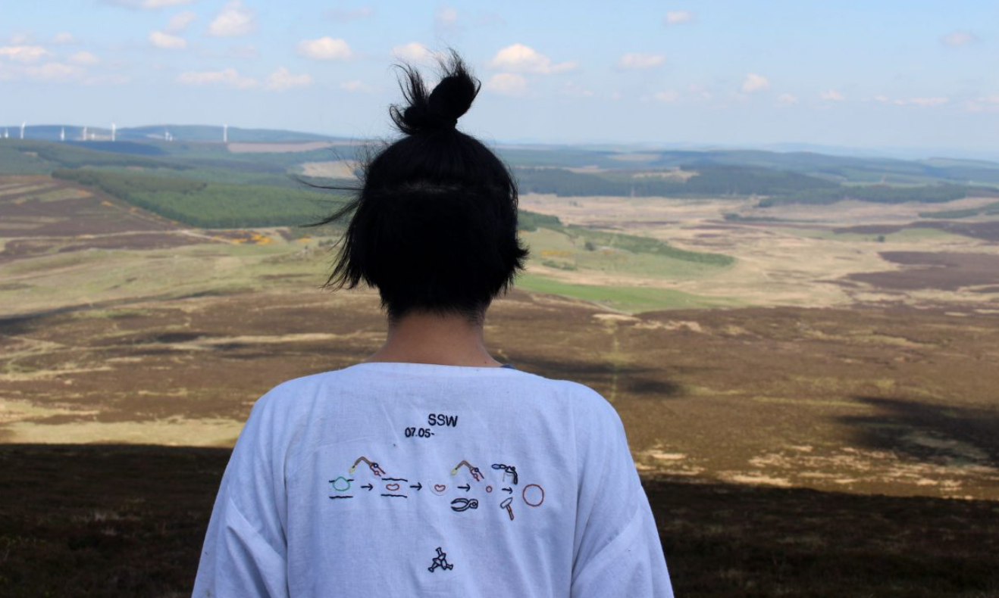
Image credit: SSW
Our Vision, Mission and Values
Vision
SSW expands the possibilities of what sculpture can be - continuously working towards positive social and environmental change.
Mission
SSW is embedded in our rural location, with a global outlook and reach. Our artist residencies and locally focussed programmes are set up to rethink and push material and skills based learning, prioritising process and opening up our workshop space as a site where community, creativity and nourishment are a driving force in all that we do.
Values
Transformative access
Time and space to make is transformative and should be accessible to all. We prioritise access across our site and programmes. We commit to work with partners, communities and professionals to ensure that barriers (physical, environmental and organisational) at SSW are identified and broken down.
Listen, learn and make change
SSW believes that we are all simultaneously learners and teachers and that learning is enabled by working together in a safe and supportive environment. As an organisation we actively work to listen, (un)learn and reimagine what is possible in resistance to dominant narratives.
Collaboration and skill sharing
We work together with collective aims and approaches, valuing the unique perspectives, lived experiences and skills that are held by those we work with. We are here to support artists and our local community and bring together their diverse knowledge and skills to create an open and empowering environment.
Respect and empowerment
Our collective learning makes us powerful! We want to empower each other to shape new visions for the world and believe that this is only possible with respect for ourselves, each other and the environment.

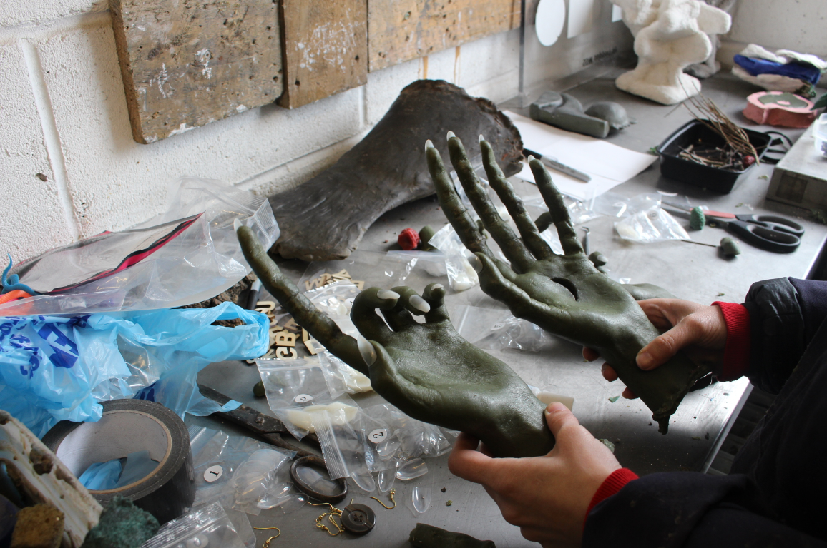
Image credit: SSW
How To Apply and Recruitment Process
Please apply using this online form and tell us, either in writing of no more than two pages or in a video of up to 5-minutes in length:
- Why you would like to become the Summer Technician at SSW this year and how you will contribute to SSW’s vision?
- Outline details of your experience and proven track record including how you meet the points outlined in the Job Description and Person Specification.
- Please include information about your skills in metal fabrication, casting, ceramics and experience sharing these skills
- Earliest available start date in June and last availability in September
- The names of two referees (only contacted after seeking permission)

Please also include your CV (maximum 2 pages) and complete our Equal Opportunities Monitoring form (this is for monitoring purposes only and will be detached from your application). You are also welcome to include up to 6 images of previous technical work.

Please note that the online form does not save automatically so please work on a separate document and upload once you have completed this.

Applications will be reviewed by a panel made up of the SSW team. We will then contact shortlisted applicants to join us for an interview and a site/ workshop visit.

The interview will consist of a short task followed by questions. Interview questions will be sent in advance.

Non-discrimination at SSW
At SSW we recognise the historic and ongoing omission of diversity within both the arts and technical fields across Scotland and our role within this. We believe this lack of diversity has led to narrower visions for what sculpture can be and who is able to make and enjoy it. We are committed to a culture of diversity, equity, and inclusion and providing equal opportunities across our organisation. We welcome applications from all backgrounds including, but not limited to, those who identify as from marginalised backgrounds based on any protected characteristic including age, race, gender identity or sexuality, disability or long-term health condition, pregnancy, maternity or marital status, religion or belief, and socio-economic background or class identity.

If you would find it more accessible to complete any part of this application in a different format, please email arts@ssw.org.uk

